Temperature Forecast Project using ML

October 24, 2021

# 1 Problem Statement:

### Data Set Information:

This data is for the purpose of bias correction of next-day maximum and minimum air temper- atures forecast of the LDAPS model operated by the Korea Meteorological Administration over Seoul, South Korea. This data consists of summer data from 2013 to 2017. The input data is largely composed of the LDAPS model’s next-day forecast data, in-situ maximum and minimum temperatures of present-day, and geographic auxiliary variables. There are two outputs (i.e. next- day maximum and minimum air temperatures) in this data. Hindcast validation was conducted for the period from 2015 to 2017.

### Attribute Information:

For more information, read [Cho et al, 2020].

1. station - used weather station number: 1 to 25

2. Date - Present day: yyyy-mm-dd (‘2013-06-30’ to ‘2017-08-30’)

3. Present_Tmax - Maximum air temperature between 0 and 21 h on the present day (Â°C): 20 to 37.6

4. Present_Tmin - Minimum air temperature between 0 and 21 h on the present day (Â°C): 11.3 to 29.9

5. LDAPS_RHmin - LDAPS model forecast of next-day minimum relative humidity (%): 19.8 to

98.5

6. LDAPS_RHmax - LDAPS model forecast of next-day maximum relative humidity (%):

58.9 to 100

7. LDAPS_Tmax_lapse - LDAPS model forecast of next-day maximum air temperature applied lapse rate (Â°C): 17.6 to 38.5

8. LDAPS_Tmin_lapse - LDAPS model forecast of next-day minimum air temperature applied lapse rate (Â°C): 14.3 to 29.6

9. LDAPS_WS - LDAPS model forecast of next-day average wind speed (m/s): 2.9 to 21.9

10. LDAPS_LH - LDAPS model fore- cast of next-day average latent heat flux (W/m2): -13.6 to 213.4

11. LDAPS_CC1 - LDAPS model forecast of next-day 1st 6-hour split average cloud cover (0-5 h) (%): 0 to 0.97

12. LDAPS_CC2 - LDAPS model forecast of next-day 2nd 6-hour split average cloud cover (6-11 h) (%): 0 to 0.97

13. LDAPS_CC3 - LDAPS model forecast of next-day 3rd 6-hour split average cloud cover (12-17

h) (%): 0 to 0.98

14. LDAPS_CC4 - LDAPS model forecast of next-day 4th 6-hour split average cloud cover (18-23 h) (%): 0 to 0.97

15. LDAPS_PPT1 - LDAPS model forecast of next-day 1st 6-hour split average precipitation (0-5 h) (%): 0 to 23.7

16. LDAPS_PPT2 - LDAPS model fore- cast of next-day 2nd 6-hour split average precipitation (6-11 h) (%): 0 to 21.6

17. LDAPS_PPT3 - LDAPS model forecast of next-day 3rd 6-hour split average precipitation (12-17 h) (%): 0 to

15.8

18. LDAPS_PPT4 - LDAPS model forecast of next-day 4th 6-hour split average precipita- tion (18-23 h) (%): 0 to 16.7

19. lat - Latitude (Â°): 37.456 to 37.645

20. lon - Longitude (Â°): 126.826 to 127.135

21. DEM - Elevation (m): 12.4 to 212.3

22. Slope - Slope (Â°): 0.1 to 5.2

23. Solar radiation - Daily incoming solar radiation (wh/m2): 4329.5 to 5992.9

24. Next_Tmax - The next-day maximum air temperature (Â°C): 17.4 to 38.9

25. Next_Tmin - The next-day minimum air temperature (Â°C): 11.3 to 29.8T

**import pandas as pd import numpy as np import seaborn as sns**

**import matplotlib.pyplot as plt import plotly.express as px import warnings** warnings.filterwarnings('ignore')

[2]:

[5]:

df = pd.read_csv("temperature.csv") df.head()

[5]: station Date Present_Tmax Present_Tmin LDAPS_RHmin LDAPS_RHmax \

|  |  |  |  |  |  |  |  |  |
| --- | --- | --- | --- | --- | --- | --- | --- | --- |
| 0 | 1.0 | 30-06-2013 | | 28.7 | 21.4 58.255688 | | 91.116364 | |
| 1 | 2.0 | 30-06-2013 | | 31.9 | 21.6 52.263397 | | 90.604721 | |
| 2 | 3.0 | 30-06-2013 | | 31.6 | 23.3 48.690479 | | 83.973587 | |
| 3 | 4.0 | 30-06-2013 | | 32.0 | 23.4 58.239788 | | 96.483688 | |
| 4 | 5.0 | 30-06-2013 | | 31.4 | 21.9 56.174095 | | 90.155128 | |
| LDAPS_Tmax_lapse | | | LDAPS_Tmin_lapse | | LDAPS_WS | LDAPS_LH … | LDAPS_PPT2 | \ |
| 0 28.074101 | | | 23.006936 | | 6.818887 | 69.451805 … | 0.0 |  |
| 1 29.850689 | | | 24.035009 | | 5.691890 | 51.937448 … | 0.0 |  |
| 2 30.091292 | | | 24.565633 | | 6.138224 | 20.573050 … | 0.0 |  |
| 3 29.704629 | | | 23.326177 | | 5.650050 | 65.727144 … | 0.0 |  |
| 4 29.113934 | | | 23.486480 | | 5.735004 | 107.965535 … | 0.0 |  |

LDAPS_PPT3 LDAPS_PPT4 lat lon DEM Slope \ 0 0.0 0.0 37.6046 126.991 212.3350 2.7850

1 0.0 0.0 37.6046 127.032 44.7624 0.5141

2 0.0 0.0 37.5776 127.058 33.3068 0.2661

3 0.0 0.0 37.6450 127.022 45.7160 2.5348

4 0.0 0.0 37.5507 127.135 35.0380 0.5055

Solar radiation Next_Tmax Next_Tmin

|  |  |  |  |
| --- | --- | --- | --- |
| 0 | 5992.895996 | 29.1 | 21.2 |
| 1 | 5869.312500 | 30.5 | 22.5 |
| 2 | 5863.555664 | 31.1 | 23.9 |
| 3 | 5856.964844 | 31.7 | 24.3 |
| 4 | 5859.552246 | 31.2 | 22.5 |
| [5 | rows x 25 columns] |  |  |

[6]:

df.shape

[6]: (7752, 25)

Dataset has 7752 rows and 25 columns.

[7]:

df.nunique()

|  |  |  |
| --- | --- | --- |
| [7]: | station | 25 |
|  | Date | 310 |
|  | Present_Tmax | 167 |
|  | Present_Tmin | 155 |
|  | LDAPS_RHmin | 7672 |
|  | LDAPS_RHmax | 7664 |
|  | LDAPS_Tmax_lapse | 7675 |
|  | LDAPS_Tmin_lapse | 7675 |
|  | LDAPS_WS | 7675 |
|  | LDAPS_LH | 7675 |
|  | LDAPS_CC1 | 7569 |
|  | LDAPS_CC2 | 7582 |
|  | LDAPS_CC3 | 7599 |
|  | LDAPS_CC4 | 7524 |
|  | LDAPS_PPT1 | 2812 |
|  | LDAPS_PPT2 | 2510 |
|  | LDAPS_PPT3 | 2356 |
|  | LDAPS_PPT4 | 1918 |
|  | lat | 12 |
|  | lon | 25 |
|  | DEM | 25 |
|  | Slope | 27 |
|  | Solar radiation | 1575 |
|  | Next_Tmax | 183 |
|  | Next_Tmin | 157 |
|  | dtype: int64 |  |

[8]:

There are no identifier or constant columns. Looking at date it looks like we have data for 320 days.

1. : station 2

df.isnull().sum()

Date 2

Present_Tmax 70

Present_Tmin 70

LDAPS_RHmin 75

LDAPS_RHmax 75

LDAPS_Tmax_lapse 75

LDAPS_Tmin_lapse 75

LDAPS_WS 75

LDAPS_LH 75

LDAPS_CC1 75

LDAPS_CC2 75

LDAPS_CC3 75

LDAPS_CC4 75

LDAPS_PPT1 75

LDAPS_PPT2 75

|  |  |
| --- | --- |
| LDAPS_PPT3 | 75 |
| LDAPS_PPT4 | 75 |
| lat | 0 |
| lon | 0 |
| DEM | 0 |
| Slope | 0 |
| Solar radiation | 0 |
| Next_Tmax | 27 |
| Next_Tmin | 27 |
| dtype: int64 |  |

There are several null values in the dataset.

[9]:

df.dtypes

1. : station float64 Date object

Present_Tmax float64

Present_Tmin float64

LDAPS_RHmin float64

LDAPS_RHmax float64 LDAPS_Tmax_lapse float64 LDAPS_Tmin_lapse float64 LDAPS_WS float64

LDAPS_LH float64

LDAPS_CC1 float64

LDAPS_CC2 float64

LDAPS_CC3 float64

LDAPS_CC4 float64

LDAPS_PPT1 float64

LDAPS_PPT2 float64

LDAPS_PPT3 float64

LDAPS_PPT4 float64

lat float64

lon float64

DEM float64

Slope float64

Solar radiation float64 Next_Tmax float64

Next_Tmin float64 dtype: object

All the datatypes are in float except for the date column.

[10]:

df.skew()

[10]: station 0.000000

Present_Tmax -0.262942

|  |  |
| --- | --- |
| Present_Tmin | -0.365875 |
| LDAPS_RHmin | 0.298765 |
| LDAPS_RHmax | -0.850870 |
| LDAPS_Tmax_lapse | -0.226775 |
| LDAPS_Tmin_lapse | -0.578943 |
| LDAPS_WS | 1.571581 |
| LDAPS_LH | 0.670491 |
| LDAPS_CC1 | 0.457231 |
| LDAPS_CC2 | 0.470060 |
| LDAPS_CC3 | 0.637630 |
| LDAPS_CC4 | 0.663251 |
| LDAPS_PPT1 | 5.367675 |
| LDAPS_PPT2 | 5.747360 |
| LDAPS_PPT3 | 6.425829 |
| LDAPS_PPT4 | 6.792379 |
| lat | 0.087062 |
| lon | -0.285213 |
| DEM | 1.723257 |
| Slope | 1.563020 |
| Solar radiation | -0.511210 |
| Next_Tmax | -0.339607 |
| Next_Tmin | -0.403743 |
| dtype: float64 |  |

There is skewness present in many continuous columns.

[11]:

*#Setting option to see all the columns.*

pd.set_option('display.max_columns', **None**)

[12]:

df.describe()

|  |  |  |  |  |  |  |
| --- | --- | --- | --- | --- | --- | --- |
| [12]: |  | station | Present_Tmax | Present_Tmin | LDAPS_RHmin | LDAPS_RHmax \ |
|  | count | 7750.000000 | 7682.000000 | 7682.000000 | 7677.000000 | 7677.000000 |
|  | mean | 13.000000 | 29.768211 | 23.225059 | 56.759372 | 88.374804 |
|  | std | 7.211568 | 2.969999 | 2.413961 | 14.668111 | 7.192004 |
|  | min | 1.000000 | 20.000000 | 11.300000 | 19.794666 | 58.936283 |
|  | 25 | 7.000000 | 27.800000 | 21.700000 | 45.963543 | 84.222862 |
|  | 50 | 13.000000 | 29.900000 | 23.400000 | 55.039024 | 89.793480 |
|  | 75 | 19.000000 | 32.000000 | 24.900000 | 67.190056 | 93.743629 |
|  | max | 25.000000 | 37.600000 | 29.900000 | 98.524734 | 100.000153 |

|  |  |  |  |  |
| --- | --- | --- | --- | --- |
|  | LDAPS_Tmax_lapse | LDAPS_Tmin_lapse | LDAPS_WS | LDAPS_LH \ |
| count | 7677.000000 | 7677.000000 | 7677.000000 | 7677.000000 |
| mean | 29.613447 | 23.512589 | 7.097875 | 62.505019 |
| std | 2.947191 | 2.345347 | 2.183836 | 33.730589 |
| min | 17.624954 | 14.272646 | 2.882580 | -13.603212 |
| 25 | 27.673499 | 22.089739 | 5.678705 | 37.266753 |
| 50 | 29.703426 | 23.760199 | 6.547470 | 56.865482 |

|  |  |  |  |  |  |  |  |  |
| --- | --- | --- | --- | --- | --- | --- | --- | --- |
| 75 | 31.710450 | | 25.152909 | 8.032276 | | 84.223616 | | |
| max | 38.542255 | | 29.619342 | 21.857621 | | 213.414006 | | |
|  | LDAPS_CC1 | LDAPS_CC2 | LDAPS_CC3 | LDAPS_CC4 | | LDAPS_PPT1 | | \ |
| count | 7677.000000 | 7677.000000 | 7677.000000 | 7677.000000 | | 7677.000000 | |  |
| mean | 0.368774 | 0.356080 | 0.318404 | 0.299191 | | 0.591995 | |  |
| std | 0.262458 | 0.258061 | 0.250362 | 0.254348 | | 1.945768 | |  |
| min | 0.000000 | 0.000000 | 0.000000 | 0.000000 | | 0.000000 | |  |
| 25 | 0.146654 | 0.140615 | 0.101388 | 0.081532 | | 0.000000 | |  |
| 50 | 0.315697 | 0.312421 | 0.262555 | 0.227664 | | 0.000000 | |  |
| 75 | 0.575489 | 0.558694 | 0.496703 | 0.499489 | | 0.052525 | |  |
| max | 0.967277 | 0.968353 | 0.983789 | 0.974710 | | 23.701544 | |  |
|  | LDAPS_PPT2 | LDAPS_PPT3 | LDAPS_PPT4 | lat | | lon | | \ |
| count | 7677.000000 | 7677.000000 | 7677.000000 | 7752.000000 | | 7752.000000 | |  |
| mean | 0.485003 | 0.278200 | 0.269407 | 37.544722 | | 126.991397 | |  |
| std | 1.762807 | 1.161809 | 1.206214 | 0.050352 | | 0.079435 | |  |
| min | 0.000000 | 0.000000 | 0.000000 | 37.456200 | | 126.826000 | |  |
| 25 | 0.000000 | 0.000000 | 0.000000 | 37.510200 | | 126.937000 | |  |
| 50 | 0.000000 | 0.000000 | 0.000000 | 37.550700 | | 126.995000 | |  |
| 75 | 0.018364 | 0.007896 | 0.000041 | 37.577600 | | 127.042000 | |  |
| max | 21.621661 | 15.841235 | 16.655469 | 37.645000 | | 127.135000 | |  |
|  | DEM | Slope | Solar radiation | | Next_Tmax | | Next_Tmin | |
| count | 7752.000000 | 7752.000000 | 7752.000000 | | 7725.000000 | | 7725.000000 | |
| mean | 61.867972 | 1.257048 | 5341.502803 | | 30.274887 | | 22.932220 | |
| std | 54.279780 | 1.370444 | 429.158867 | | 3.128010 | | 2.487613 | |
| min | 12.370000 | 0.098475 | 4329.520508 | | 17.400000 | | 11.300000 | |
| 25 | 28.700000 | 0.271300 | 4999.018555 | | 28.200000 | | 21.300000 | |
| 50 | 45.716000 | 0.618000 | 5436.345215 | | 30.500000 | | 23.100000 | |
| 75 | 59.832400 | 1.767800 | 5728.316406 | | 32.600000 | | 24.600000 | |
| max | 212.335000 | 5.178230 | 5992.895996 | | 38.900000 | | 29.800000 | |



[13]:

Count is different in different row indicating missing values. Mean is not equal to median, data does not follow normal distribution. There is high variance in solar radiation column while some columns such as lon and lat have variance close to zero. Difference between minimum, maximum and interquartile range is m=not equal which indicates presence of outliers.

# Exploratory Data Analysis

## Univariate Analysis

*#Separating categorical and continuous variables with respect to uniqueness of*␣

*‹→columns*

cont=[i **for** i **in** df.columns **if** df[i].nunique()>30 **and** i!='Date'] cat=[i **for** i **in** df.columns **if** df[i].nunique()<30]

[14]:

plt.figure(figsize=(15,8)) sns.countplot(x='Slope',data=df) plt.xticks(rotation=90) df['Slope'].value_counts()

[14]: 0.697000 310

0.266100 310

0.623300 310

2.785000 310

0.572100 310

0.098500 310

0.412500 310

2.686500 310

0.222300 310

0.155400 310

0.514100 310

5.178200 310

2.534800 310

0.855200 310

2.257900 310

0.133200 310

1.231300 310

1.562900 310

0.593100 310

0.505500 310

0.271300 310

0.145700 310

0.618000 310

1.767800 310

4.729600 310

0.098475 1

5.178230 1

Name: Slope, dtype: int64

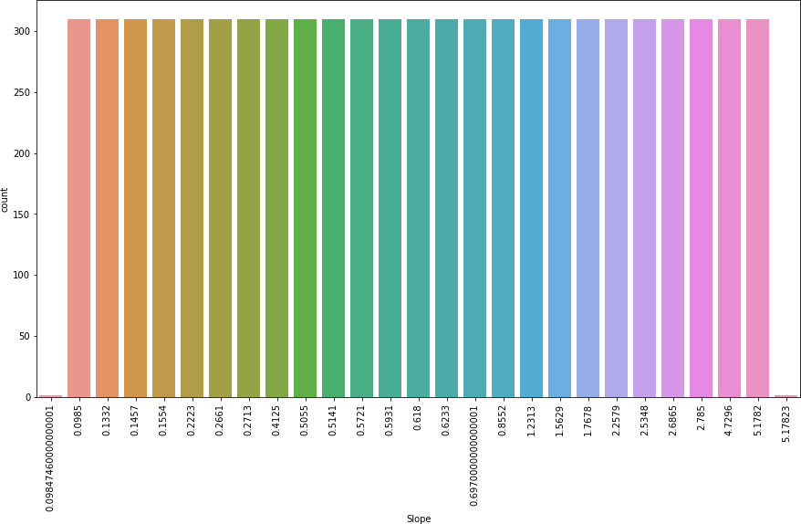

[15]:

plt.figure(figsize=(15,8)) sns.countplot(x='DEM',data=df) plt.xticks(rotation=90) df['DEM'].value_counts()

All the slope values have equal no. of counts except for 2 slopes which have only one count each. These values seem to belong to their rounded of categories respectively.

|  |  |  |
| --- | --- | --- |
| [15]: | 12.3700 | 311 |
|  | 212.3350 | 311 |
|  | 146.5540 | 310 |
|  | 82.2912 | 310 |
|  | 54.6384 | 310 |
|  | 35.0380 | 310 |
|  | 17.2956 | 310 |
|  | 52.5180 | 310 |
|  | 75.0924 | 310 |
|  | 15.5876 | 310 |
|  | 132.1180 | 310 |
|  | 56.4448 | 310 |
|  | 21.9668 | 310 |
|  | 26.2980 | 310 |
|  | 28.7000 | 310 |
|  | 33.3068 | 310 |

|  |  |  |
| --- | --- | --- |
| 59.8324 | 310 |  |
| 53.4712 | 310 |  |
| 50.9312 | 310 |  |
| 208.5070 | 310 |  |
| 19.5844 | 310 |  |
| 30.9680 | 310 |  |
| 44.7624 | 310 |  |
| 30.0464 | 310 |  |
| 45.7160 | 310 |  |
| Name: DEM, | dtype: | int64 |

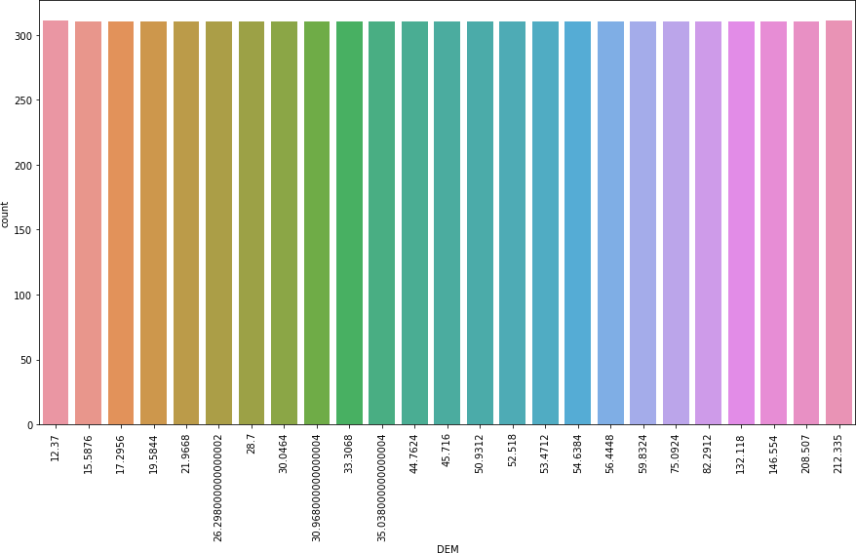

All the elevations have same count equal to 310 except two who have 311 counts each.

[17]:

plt.figure(figsize=(15,8)) sns.countplot(x='lon',data=df) plt.xticks(rotation=90) df['lon'].value_counts()

|  |  |
| --- | --- |
| [17]: 127.135 | 311 |
| 126.826 | 311 |
| 126.995 | 310 |
| 126.937 | 310 |
| 126.991 | 310 |
| 126.988 | 310 |

|  |  |  |
| --- | --- | --- |
| 127.024 | 310 |  |
| 127.086 | 310 |  |
| 127.022 | 310 |  |
| 126.970 | 310 |  |
| 126.838 | 310 |  |
| 127.042 | 310 |  |
| 127.058 | 310 |  |
| 127.040 | 310 |  |
| 126.891 | 310 |  |
| 127.032 | 310 |  |
| 127.099 | 310 |  |
| 127.083 | 310 |  |
| 126.938 | 310 |  |
| 126.909 | 310 |  |
| 126.910 | 310 |  |
| 127.004 | 310 |  |
| 126.927 | 310 |  |
| 126.955 | 310 |  |
| 127.085 | 310 |  |
| Name: lon, | dtype: | int64 |

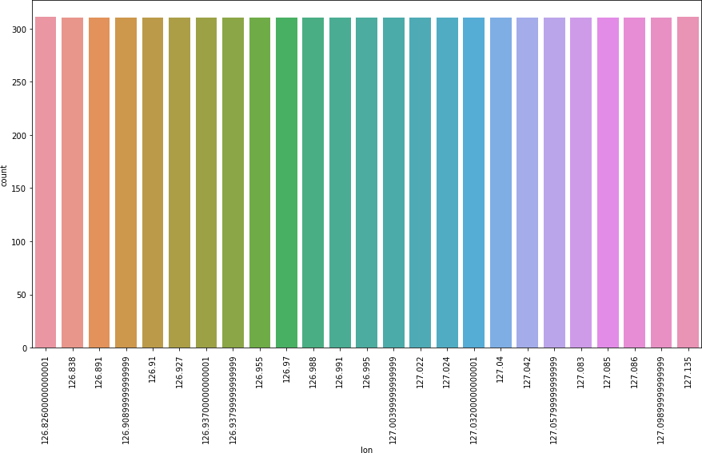

All the longitude have smae count equal to 310 except two longitudes that have 311 counts each.

[18]:



plt.figure(figsize=(15,8)) plt.subplot(1,2,1)

df['lat'].value_counts().plot.pie(autopct=' **1.1f**') centre=plt.Circle((0,0),0.7,fc='pink')

fig=plt.gcf() fig.gca().add_artist(centre) plt.subplot(1,2,2) sns.countplot(x='lat',data=df) plt.xticks(rotation=45) df['lat'].value_counts()

|  |  |  |  |
| --- | --- | --- | --- |
| [18]: | 37.5776 | 1240 |  |
|  | 37.5507 | 1240 |  |
|  | 37.5237 | 620 |  |
|  | 37.4697 | 620 |  |
|  | 37.5102 | 620 |  |
|  | 37.6181 | 620 |  |
|  | 37.4967 | 620 |  |
|  | 37.6046 | 620 |  |
|  | 37.5372 | 620 |  |
|  | 37.6450 | 311 |  |
|  | 37.4562 | 311 |  |
|  | 37.4832 | 310 |  |
|  | Name: lat, | dtype: | int64 |

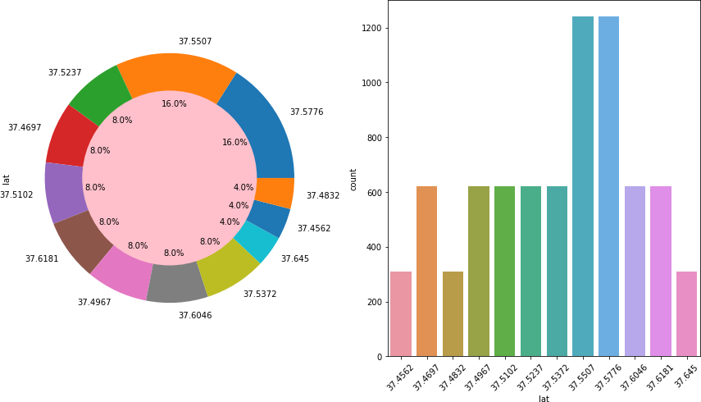

There are 12 latitudes present, two of which have the highest count equal to 1240 while 7 of them

have 620 counts and rest 3 have less than 350 counts.

[19]:



plt.figure(figsize=(15,8)) plt.subplot(1,2,1)

df['station'].value_counts().plot.pie(autopct=' **1.1f** ') centre=plt.Circle((0,0),0.7,fc='blue')

fig=plt.gcf() fig.gca().add_artist(centre) plt.subplot(1,2,2) sns.countplot(x='station',data=df) plt.xticks(rotation=45) df['station'].value_counts()

|  |  |  |  |
| --- | --- | --- | --- |
| [19]: | 25.0 | 310 |  |
|  | 12.0 | 310 |  |
|  | 2.0 | 310 |  |
|  | 3.0 | 310 |  |
|  | 4.0 | 310 |  |
|  | 5.0 | 310 |  |
|  | 6.0 | 310 |  |
|  | 7.0 | 310 |  |
|  | 8.0 | 310 |  |
|  | 9.0 | 310 |  |
|  | 10.0 | 310 |  |
|  | 11.0 | 310 |  |
|  | 13.0 | 310 |  |
|  | 23.0 | 310 |  |
|  | 14.0 | 310 |  |
|  | 15.0 | 310 |  |
|  | 16.0 | 310 |  |
|  | 18.0 | 310 |  |
|  | 20.0 | 310 |  |
|  | 22.0 | 310 |  |
|  | 24.0 | 310 |  |
|  | 17.0 | 310 |  |
|  | 19.0 | 310 |  |
|  | 21.0 | 310 |  |
|  | 1.0 | 310 |  |
|  | Name: | station, | dtype: int64 |

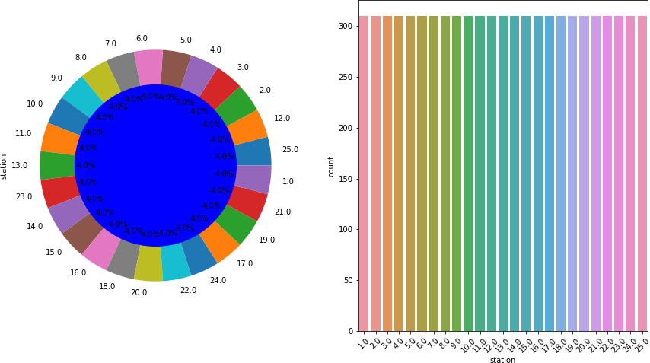

There are 25 stations each of them have 310 observations.

[20]:

plt.figure(figsize=(15,8)) plt.subplot(1,2,1)

sns.histplot(df['Present_Tmax'],kde=**True**,color='k') plt.subplot(1,2,2) sns.histplot(df['Present_Tmin'],kde=**True**,color='g')

print('Minimum Tmax is **{}** and Maximum Tmax is **{}**'.format(df['Present_Tmax'].

*‹→*min(),df['Present_Tmax'].max()))

print('Minimum Tmin is **{}** and Maximum Tmin is **{}**'.format(df['Present_Tmin'].

*‹→*min(),df['Present_Tmin'].max()))

Minimum Tmax is 20.0 and Maximum Tmax is 37.6 Minimum Tmin is 11.3 and Maximum Tmin is 29.9

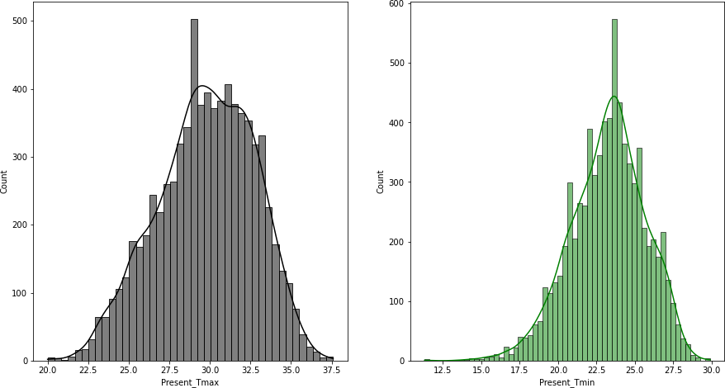

[21]:

Present Tmax and Tmin are almost normally distibuted, Tmax have highest temp as 37.6 and min as 20, most of the days have tmax equal to 28.5, while Tmin have highest temp as 29.9 and min as 11.3, most of the days have tmin equal to 23.

Minimum RHmax is 58.93628311 and Maximum RHmax is 100.00015259999999 Minimum RHmin is 19.79466629 and Maximum RHmin is 98.5247345



plt.figure(figsize=(15,8)) plt.subplot(1,2,1)

sns.histplot(df['LDAPS_RHmax'],kde=**True**,color='g') plt.title('Maximum relative humidity ( )') plt.subplot(1,2,2) sns.histplot(df['LDAPS_RHmin'],kde=**True**,color='r') plt.title('Minimum relative humidity ( )')

print('Minimum RHmax is **{}** and Maximum RHmax is **{}**'.format(df['LDAPS_RHmax'].

*‹→*min(),df['LDAPS_RHmax'].max()))

print('Minimum RHmin is **{}** and Maximum RHmin is **{}**'.format(df['LDAPS_RHmin'].

*‹→*min(),df['LDAPS_RHmin'].max()))

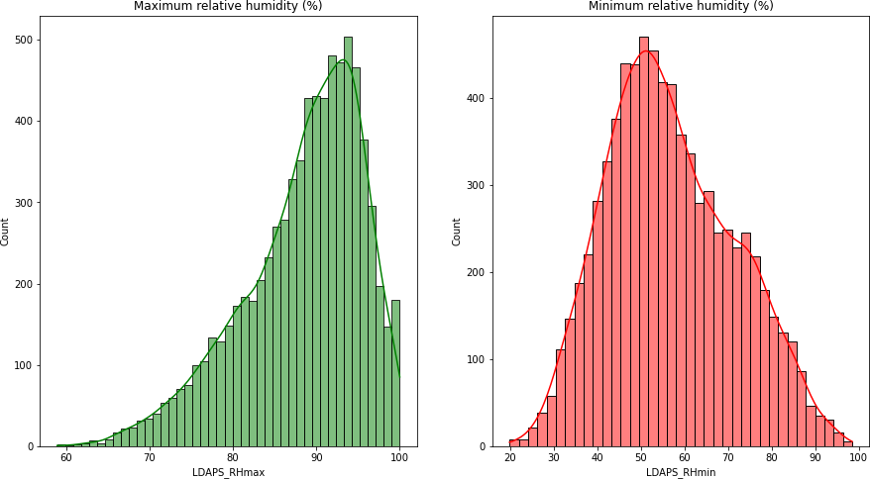

[23]:

Data of Maximum relative humidity is left skewed and Data of Maximum relative humidity is slightly right skewed. RHmax for most of the days lie in the range 92 to 97 while RHmin lies in the range 45 to 62.

Minimum Tmax applied lapse rate is 17.62495378 and Maximum Tmax applied lapse rate is 38.54225522

plt.figure(figsize=(15,8)) plt.subplot(1,2,1)

sns.histplot(df['LDAPS_Tmax_lapse'],kde=**True**,color='r') plt.subplot(1,2,2) sns.histplot(df['LDAPS_Tmin_lapse'],kde=**True**,color='b')

print('Minimum Tmax applied lapse rate is **{}** and Maximum Tmax applied lapse␣

*‹→*rate is **{}**'.format(df['LDAPS_Tmax_lapse'].min(),df['LDAPS_Tmax_lapse'].

*‹→*max()))

print('Minimum Tmin is applied lapse rate **{}** and Maximum Tmin applied lapse␣

*‹→*rate is **{}**'.format(df['LDAPS_Tmin_lapse'].min(),df['LDAPS_Tmin_lapse'].

*‹→*max()))

Minimum Tmin is applied lapse rate 14.27264631 and Maximum Tmin applied lapse rate is 29.61934244

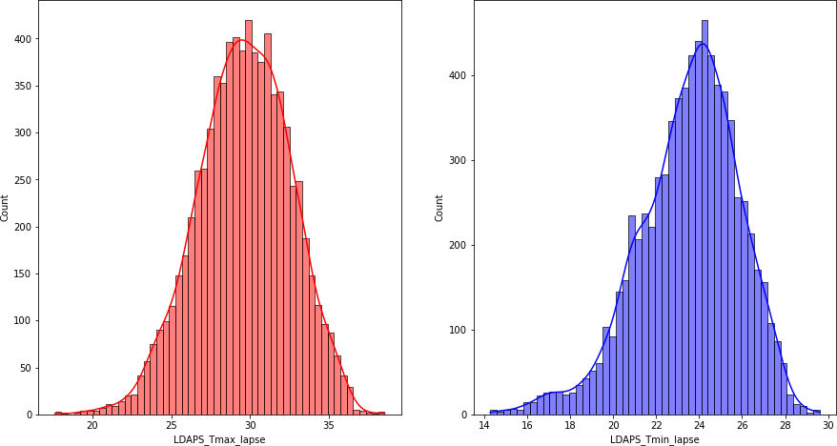

[24]:

Tmax and Tmin for applied lapse rate are almost normally distributed, with Tmax_lapse having maximum at 38.54 , minimum at 17.62 and for majority of days its values lies in the range 27 to 32 while Tmin_lapse having maximum at 29.61 , minimum at 14.27 and for majority of days its values lies in the range 23 to 26

Minimum 2.882579625

plt.figure(figsize=(8,6)) sns.histplot(df['LDAPS_WS'],kde=**True**,color='k') plt.title('Next day average Wind Speed') print('Minimum',df['LDAPS_WS'].min())

print('Maximum',df['LDAPS_WS'].max())

Maximum 21.85762099

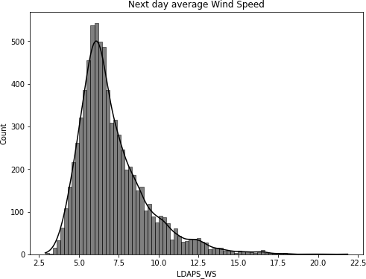

[25]:

Data of average wind speed ris right skewed. It have its minimum value at 2.88m/s and maximum values at 21.85m/s and majority of its values lies in the rabge 5m/s to 8m/s

Minimum -13.60321209

plt.figure(figsize=(8,6)) sns.histplot(df['LDAPS_LH'],kde=**True**,color='k') plt.title('Next day average Latent Heat Flux') print('Minimum',df['LDAPS_LH'].min())

print('Maximum',df['LDAPS_LH'].max())

Maximum 213.4140062

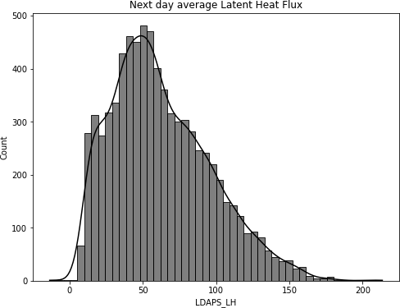

[27]:



cloud_cover=['LDAPS_CC1','LDAPS_CC2','LDAPS_CC3','LDAPS_CC4']

fig,ax=plt.subplots(2,2,figsize=(18,10)) r=0

c=0

**for** i, n **in** enumerate(cloud_cover):

**if** i **2**==0 and i>0: r+=1

c=0 sns.histplot(df[n],kde=**True**,color='k',ax=ax[r,c]) c+=1

Latent heat flux seems to be normally distributed with slight skewness to the right. It has its minimum value at -13.60 and maximum values at 213.41 and majority of its values lies in the range 30 to 70.

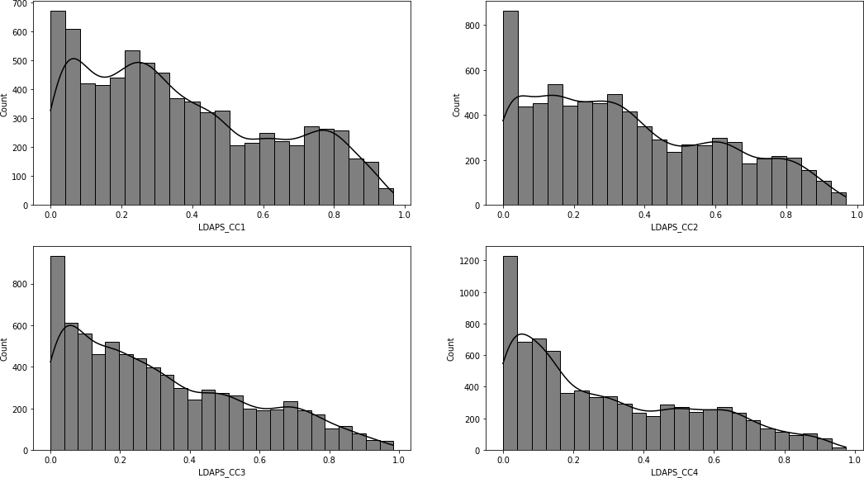

[28]:



precipitation=['LDAPS_PPT1','LDAPS_PPT2','LDAPS_PPT3','LDAPS_PPT4']

fig,ax=plt.subplots(2,2,figsize=(18,10)) r=0

c=0

**for** i, n **in** enumerate(precipitation):

**if** i **2**==0 and i>0: r+=1

c=0 sns.distplot(df[n],color='b',ax=ax[r,c]) c+=1

Cloud cover data for all the 6 hour split is right skewed and majority of all the splits values lie close to 0.

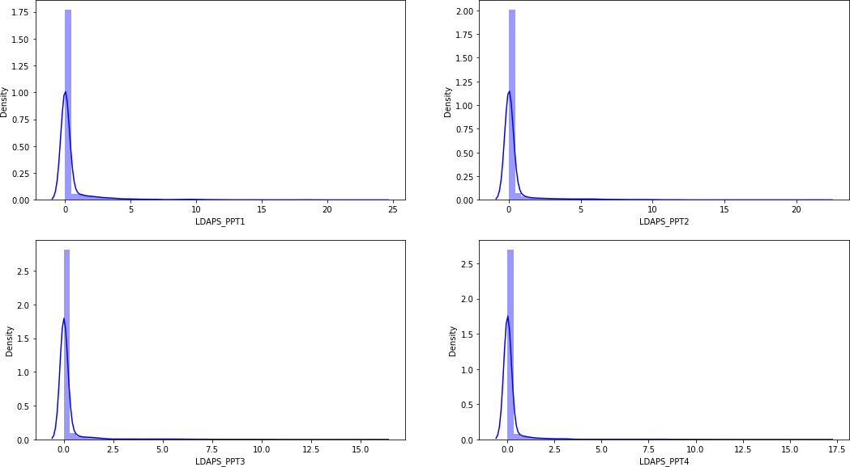

[29]:

Precipitation data for all the 6 hour split is right skewed and majority of all the splits values lie close to 0.

Minimum 4329.520508

plt.figure(figsize=(8,6))

sns.histplot(df['Solar radiation'],kde=**True**,color='k') print('Minimum',df['Solar radiation'].min()) print('Maximum',df['Solar radiation'].max())

Maximum 5992.895996

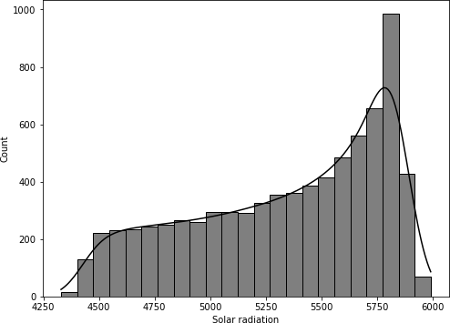

[30]:



fig,ax=plt.subplots(9,2,figsize=(15,55)) r=0

c=0

**for** i, n **in** enumerate(cont[:-2]):

**if** i **2**==0 and i>0: r+=1

c=0 sns.boxplot(df[n],color='r',ax=ax[r,c]) c+=1

Incoming Solar Radiation left skewed. It has its minimum value at 4329.52 and maximum values at 5992.89 and majority of its values lies in the range 5600 to 5850.

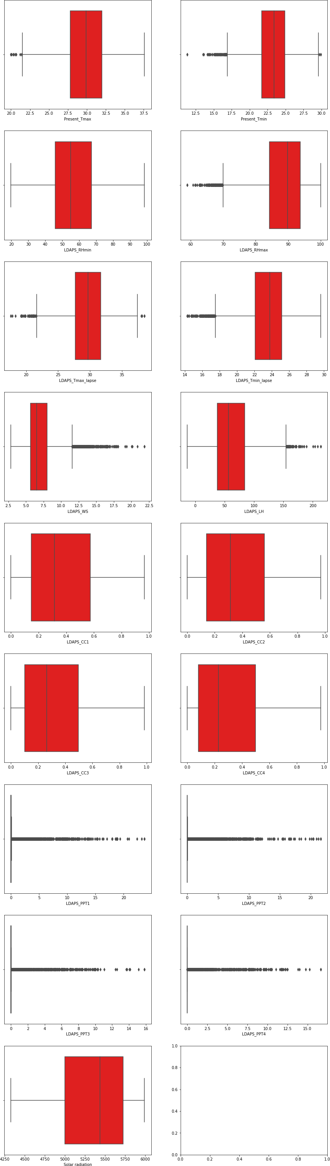

22

[31]:

There a large no. of outliers especially in the precipitation data. Latent heat flux, wind speed, temperature applied lapse rate and Rhmax also have presence of outliers. While there are few in present day tmax and tmin also.

## Bivariate Analysis

plt.figure(figsize=(15,8)) plt.subplot(2,1,1)

sns.boxplot(x='station',y='Next_Tmax',data=df) plt.subplot(2,1,2) sns.boxplot(x='station',y='Next_Tmin',data=df)

[31]: <AxesSubplot:xlabel='station', ylabel='Next_Tmin'>

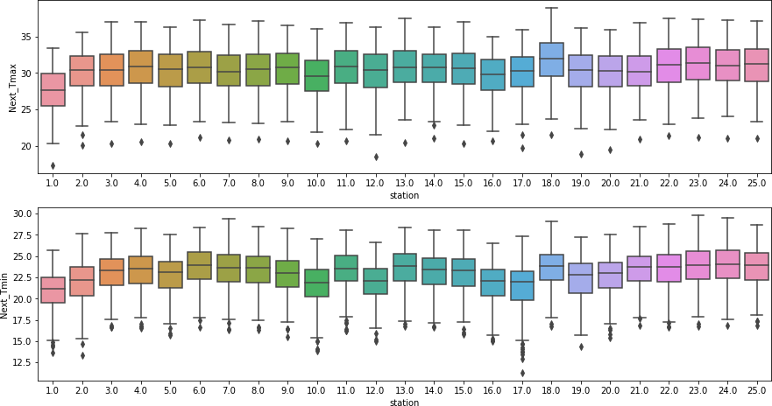

[33]:

plt.figure(figsize=(15,15)) plt.subplot(2,1,1) sns.boxplot(x='lat',y='Next_Tmax',data=df) plt.xticks(rotation=90)

plt.subplot(2,1,2) sns.boxplot(x='lat',y='Next_Tmin',data=df) plt.xticks(rotation=90)

Station 18 observes highest temperature for both Tmax and Tmin while station 1 observes lowest temperatures for both. It coud be because of their location

[33]: (array([ 0, 1, 2, 3, 4, 5, 6, 7, 8, 9, 10, 11]),

[Text(0, 0, '37.4562'),

Text(1, 0, '37.4697'),

Text(2, 0, '37.4832'),

Text(3, 0, '37.4967'),

Text(4, 0, '37.5102'),

Text(5, 0, '37.5237'),

Text(6, 0, '37.5372'),

Text(7, 0, '37.5507'),

Text(8, 0, '37.5776'),

Text(9, 0, '37.6046'),

Text(10, 0, '37.6181'),

Text(11, 0, '37.645')])

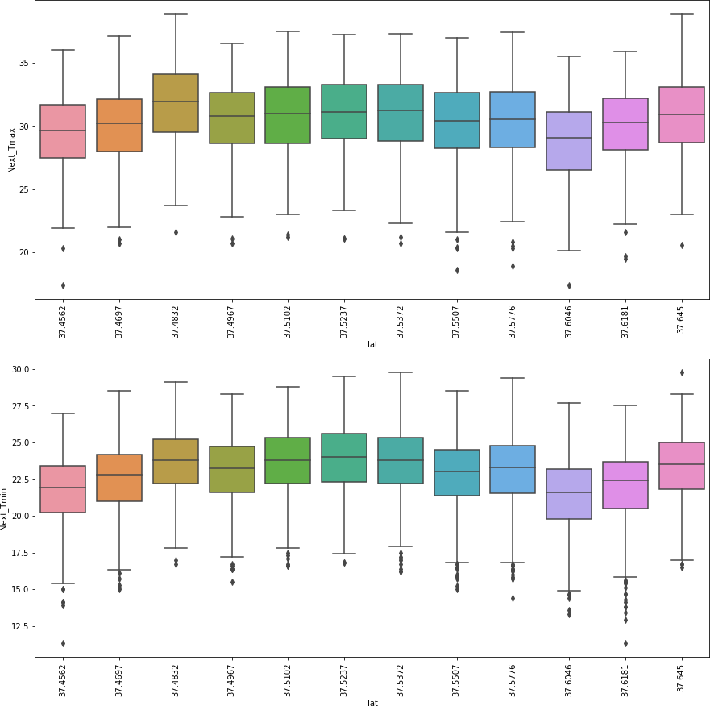

[34]:

Temperature seems to fall as the the latitude increases which is also a know fact. Highest temper- ature is observed at 37.645 for Tmax while this is not the case for tmin which could be because of the other factors that affect the temperature.

[34]: (array([ 0, 1, 2, 3, 4, 5, 6, 7, 8, 9, 10, 11, 12, 13, 14, 15, 16,

plt.figure(figsize=(15,30)) plt.subplot(2,1,1) sns.boxplot(x='lon',y='Next_Tmax',data=df) plt.xticks(rotation=90)

plt.subplot(2,1,2) sns.boxplot(x='lon',y='Next_Tmin',data=df) plt.xticks(rotation=90)

17, 18, 19, 20, 21, 22, 23, 24]),

|  |  |  |
| --- | --- | --- |
| [Text(0, | 0, | '126.82600000000001'), |
| Text(1, | 0, | '126.838'), |
| Text(2, | 0, | '126.891'), |
| Text(3, | 0, | '126.90899999999999'), |
| Text(4, | 0, | '126.91'), |
| Text(5, | 0, | '126.927'), |
| Text(6, | 0, | '126.93700000000001'), |
| Text(7, | 0, | '126.93799999999999'), |
| Text(8, | 0, | '126.955'), |
| Text(9, | 0, | '126.97'), |
| Text(10, | 0, | '126.988'), |
| Text(11, | 0, | '126.991'), |
| Text(12, | 0, | '126.995'), |
| Text(13, | 0, | '127.00399999999999'), |
| Text(14, | 0, | '127.022'), |
| Text(15, | 0, | '127.024'), |
| Text(16, | 0, | '127.03200000000001'), |
| Text(17, | 0, | '127.04'), |
| Text(18, | 0, | '127.042'), |
| Text(19, | 0, | '127.05799999999999'), |
| Text(20, | 0, | '127.083'), |
| Text(21, | 0, | '127.085'), |
| Text(22, | 0, | '127.086'), |
| Text(23, | 0, | '127.09899999999999'), |
| Text(24, | 0, | '127.135')]) |

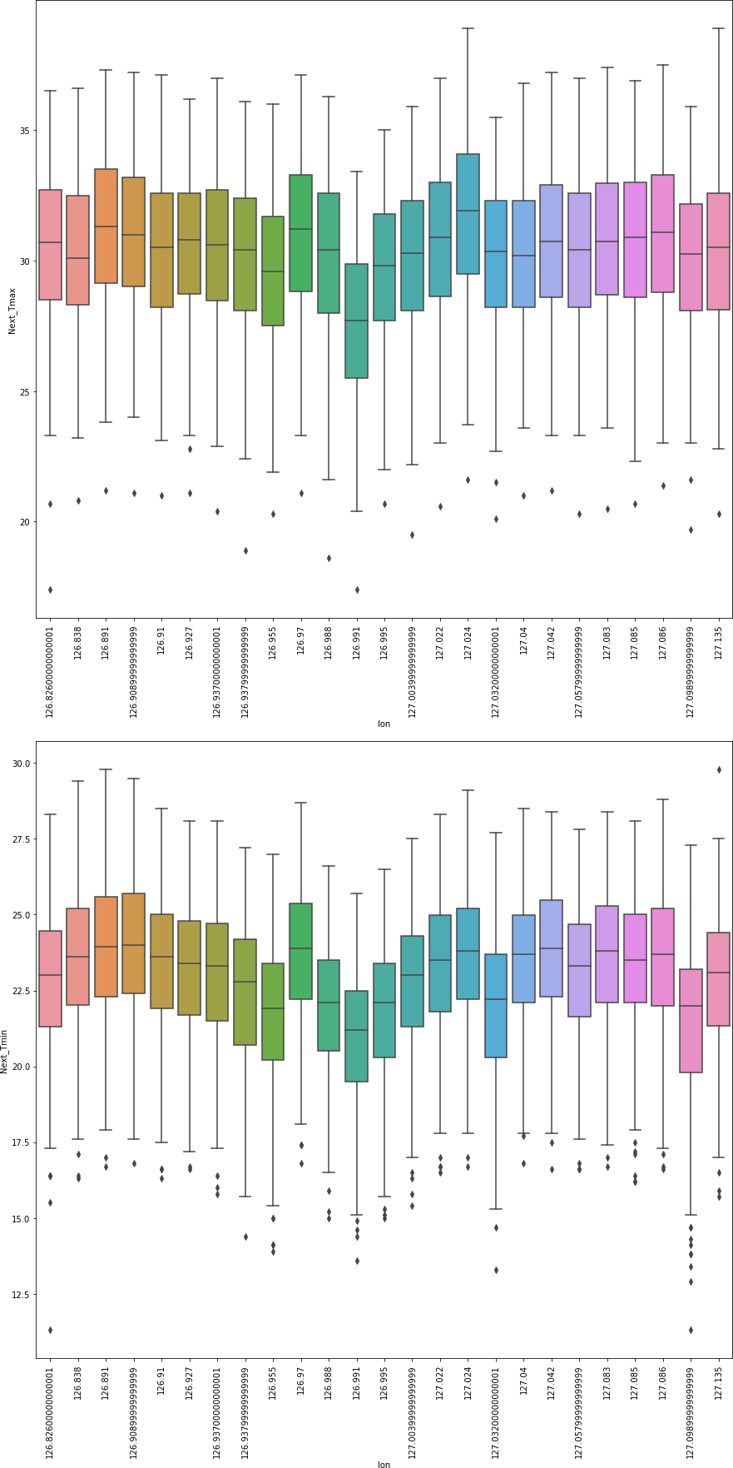

26

plt.figure(figsize=(15,30)) plt.subplot(2,1,1) sns.boxplot(x='DEM',y='Next_Tmax',data=df) plt.xticks(rotation=90)

plt.subplot(2,1,2) sns.boxplot(x='DEM',y='Next_Tmin',data=df) plt.xticks(rotation=90)

[35]:

Studies have shown that longitude does not affect the temperature of a place. While from the above graph it is seen that as the longitude increases, temperature increases for the first 4 longitudes then decreases for the next 5. This increase decrease is carried on.

[35]: (array([ 0, 1, 2, 3, 4, 5, 6, 7, 8, 9, 10, 11, 12, 13, 14, 15, 16,

17, 18, 19, 20, 21, 22, 23, 24]),

|  |  |  |
| --- | --- | --- |
| [Text(0, | 0, | '12.37'), |
| Text(1, | 0, | '15.5876'), |
| Text(2, | 0, | '17.2956'), |
| Text(3, | 0, | '19.5844'), |
| Text(4, | 0, | '21.9668'), |
| Text(5, | 0, | '26.298000000000002'), |
| Text(6, | 0, | '28.7'), |
| Text(7, | 0, | '30.0464'), |
| Text(8, | 0, | '30.968000000000004'), |
| Text(9, | 0, | '33.3068'), |
| Text(10, | 0, | '35.038000000000004'), |
| Text(11, | 0, | '44.7624'), |
| Text(12, | 0, | '45.716'), |
| Text(13, | 0, | '50.9312'), |
| Text(14, | 0, | '52.518'), |
| Text(15, | 0, | '53.4712'), |
| Text(16, | 0, | '54.6384'), |
| Text(17, | 0, | '56.4448'), |
| Text(18, | 0, | '59.8324'), |
| Text(19, | 0, | '75.0924'), |
| Text(20, | 0, | '82.2912'), |
| Text(21, | 0, | '132.118'), |
| Text(22, | 0, | '146.554'), |
| Text(23, | 0, | '208.507'), |
| Text(24, | 0, | '212.335')]) |

27

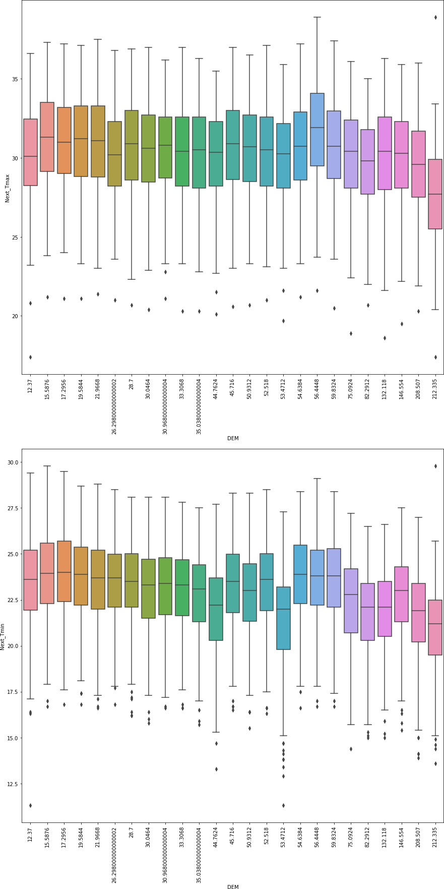

28

[36]:

Studies show that as the elevation increases, temperature decreases. This even true for our graph for the last 10 high elevations but not for all. It seems that temperature is also affected by other features rather than just elevation.

[36]: (array([ 0, 1, 2, 3, 4, 5, 6, 7, 8, 9, 10, 11, 12, 13, 14, 15, 16,

plt.figure(figsize=(15,30)) plt.subplot(2,1,1) sns.boxplot(x='Slope',y='Next_Tmax',data=df) plt.xticks(rotation=90)

plt.subplot(2,1,2) sns.boxplot(x='Slope',y='Next_Tmin',data=df) plt.xticks(rotation=90)

17, 18, 19, 20, 21, 22, 23, 24, 25, 26]),

|  |  |  |
| --- | --- | --- |
| [Text(0, | 0, | '0.09847460000000001'), |
| Text(1, | 0, | '0.0985'), |
| Text(2, | 0, | '0.1332'), |
| Text(3, | 0, | '0.1457'), |
| Text(4, | 0, | '0.1554'), |
| Text(5, | 0, | '0.2223'), |
| Text(6, | 0, | '0.2661'), |
| Text(7, | 0, | '0.2713'), |
| Text(8, | 0, | '0.4125'), |
| Text(9, | 0, | '0.5055'), |
| Text(10, | 0, | '0.5141'), |
| Text(11, | 0, | '0.5721'), |
| Text(12, | 0, | '0.5931'), |
| Text(13, | 0, | '0.618'), |
| Text(14, | 0, | '0.6233'), |
| Text(15, | 0, | '0.6970000000000001'), |
| Text(16, | 0, | '0.8552'), |
| Text(17, | 0, | '1.2313'), |
| Text(18, | 0, | '1.5629'), |
| Text(19, | 0, | '1.7678'), |
| Text(20, | 0, | '2.2579'), |
| Text(21, | 0, | '2.5348'), |
| Text(22, | 0, | '2.6865'), |
| Text(23, | 0, | '2.785'), |
| Text(24, | 0, | '4.7296'), |
| Text(25, | 0, | '5.1782'), |
| Text(26, | 0, | '5.17823')]) |

29

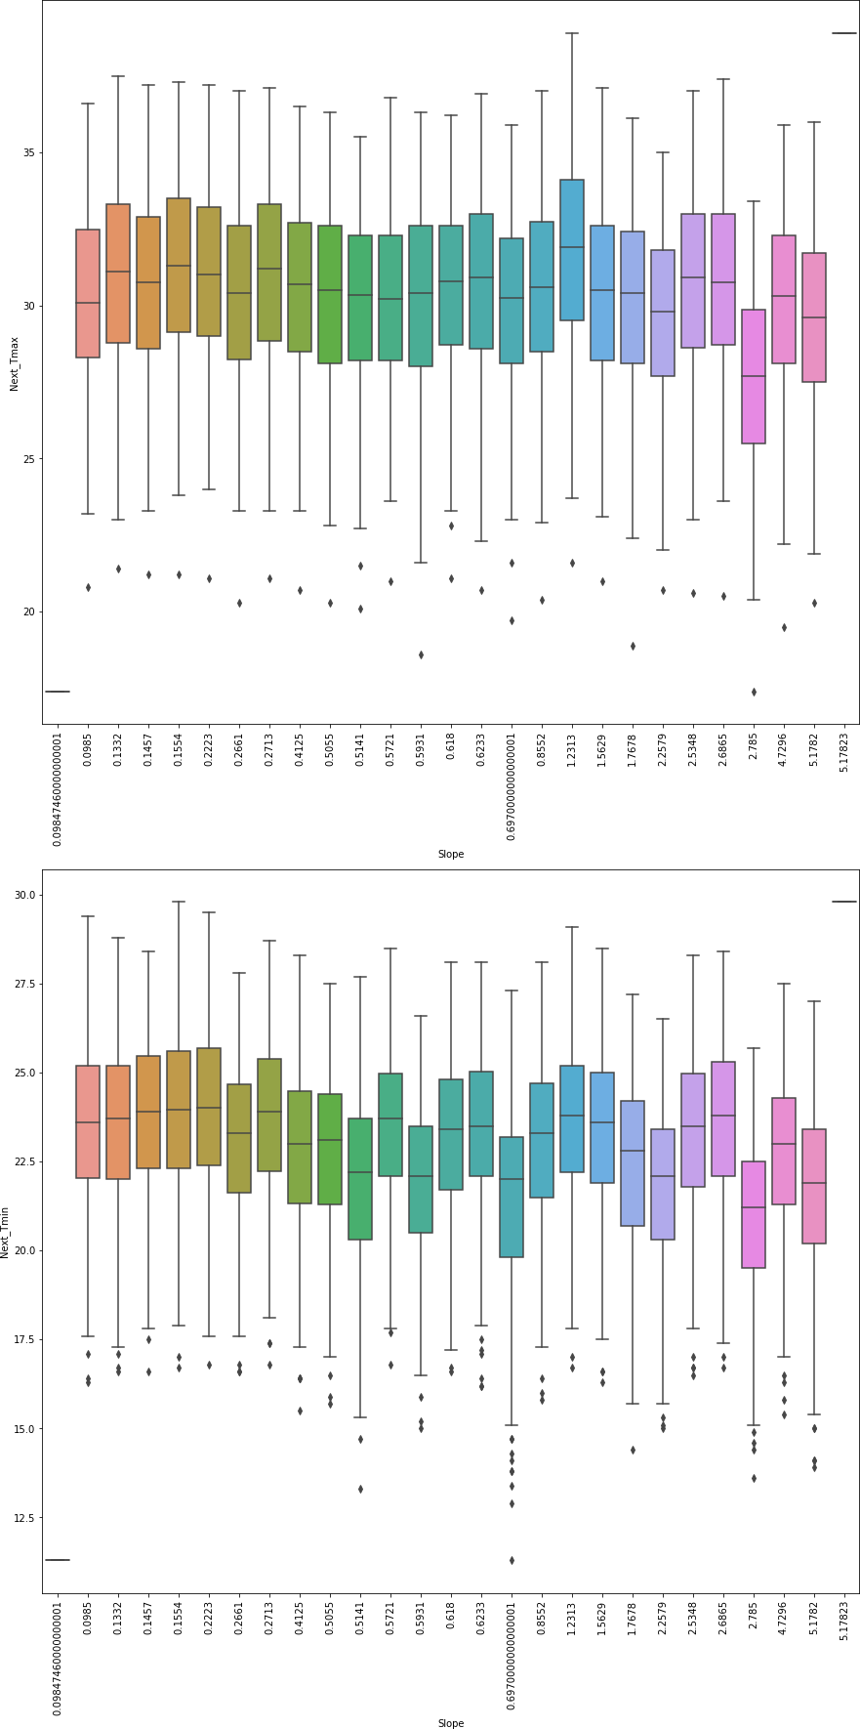

30

[38]:

A steep slope experiences a more rapid change in temperature than a gentle one thats why as rhe slopes increases the range of temperature also increases. Lowest and Highest temperatures are observed at consecutive slopes 0.697 and 0.8552 respectively

[38]: <AxesSubplot:title={'center':'Next day min Temperature Vs Present day min Temperature'}, xlabel='Present_Tmin', ylabel='Next_Tmin'>

plt.figure(figsize=(15,12))

plt.suptitle('Next day Temperature Vs Present day Temperature')

plt.subplot(2,2,1)

plt.title('Next day max Temperature Vs Present day max Temperature') sns.regplot(x='Present_Tmax',y='Next_Tmax',data=df,marker='*',color='b')

plt.subplot(2,2,2)

plt.title('Next day max Temperature Vs Present day min Temperature') sns.regplot(x='Present_Tmin',y='Next_Tmax',data=df,marker='*',color='k')

plt.subplot(2,2,3)

plt.title('Next day min Temperature Vs Present day max Temperature') sns.regplot(x='Present_Tmax',y='Next_Tmin',data=df,marker='*',color='r')

plt.subplot(2,2,4)

plt.title('Next day min Temperature Vs Present day min Temperature') sns.regplot(x='Present_Tmin',y='Next_Tmin',data=df,marker='*',color='k')

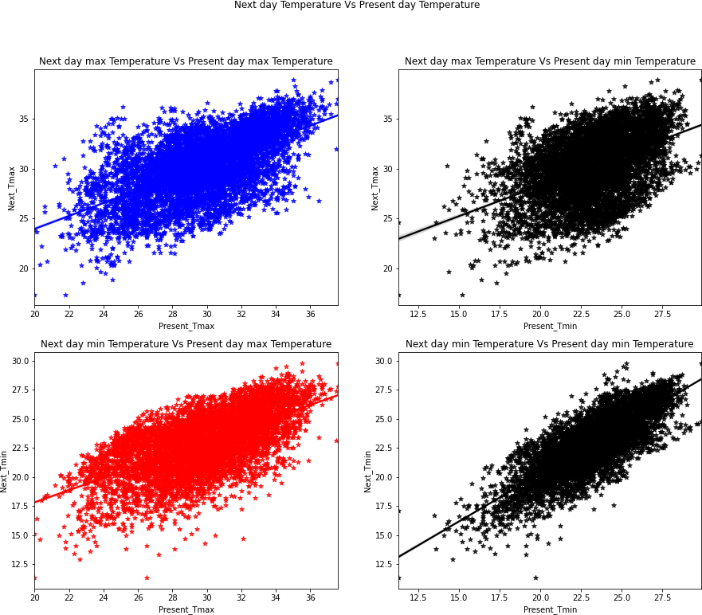

There is high positive correlation of Next day temperatures with the present day temperatures.

[40]:

plt.figure(figsize=(15,12))

plt.suptitle('Next day Temperatures Vs Present day Relative Humidity')

plt.subplot(2,2,1)

plt.title('Next day max Temperatures Vs Present day max Relative Humidity') sns.regplot(x='LDAPS_RHmax',y='Next_Tmax',data=df,marker='*',color='g')

plt.subplot(2,2,2)

plt.title('Next day max Temperatures Vs Present day min Relative Humidity') sns.regplot(x='LDAPS_RHmin',y='Next_Tmax',data=df,marker='*',color='k')

plt.subplot(2,2,3)

plt.title('Next day min Temperatures Vs Present day max Relative Humidity') sns.regplot(x='LDAPS_RHmax',y='Next_Tmin',data=df,marker='*',color='y')

plt.subplot(2,2,4)

plt.title('Next day min Temperatures Vs Present day min Relative Humidity') sns.regplot(x='LDAPS_RHmin',y='Next_Tmin',data=df,marker='*',color='k')

[40]: <AxesSubplot:title={'center':'Next day min Temperatures Vs Present day min Relative Humidity'}, xlabel='LDAPS_RHmin', ylabel='Next_Tmin'>

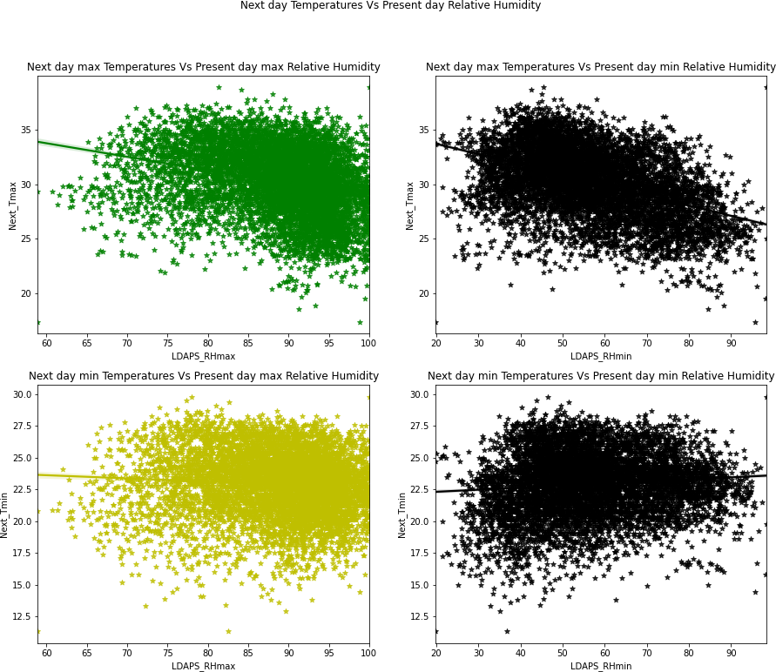

[43]:

plt.figure(figsize=(15,12))

plt.suptitle('Next day Temperatures Vs Present day Temperature applied lapse␣

*‹→*rate')

plt.subplot(2,2,1) sns.regplot(x='LDAPS_Tmax_lapse',y='Next_Tmax',data=df,marker='*',color='r')

Next day Tmax decreases with increase in RHmax and RHmin while this is not true for Tmin as Tmin seem to be unaffected by Rhmax and shows a slight positive correlation with Rhmin.

plt.subplot(2,2,2) sns.regplot(x='LDAPS_Tmin_lapse',y='Next_Tmax',data=df,marker='*',color='k')

plt.subplot(2,2,3) sns.regplot(x='LDAPS_Tmax_lapse',y='Next_Tmin',data=df,marker='*',color='g')

plt.subplot(2,2,4) sns.regplot(x='LDAPS_Tmin_lapse',y='Next_Tmin',data=df,marker='*',color='k')

1. : <AxesSubplot:xlabel='LDAPS_Tmin_lapse', ylabel='Next_Tmin'>

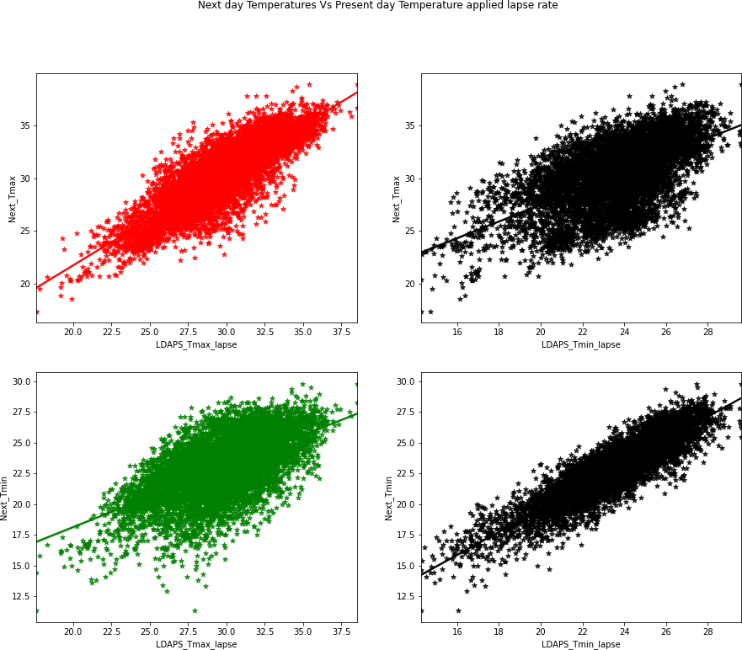

[44]:

plt.figure(figsize=(15,6))

plt.suptitle('Next day Temperatures Vs Next day average Wind Speed')

There is high positive correlation of Next day temperatures with the present day temperatures applied lapse rate. If one increases other also increases.

plt.subplot(1,2,1) sns.regplot(x='LDAPS_WS',y='Next_Tmax',data=df,marker='*',color='r')

plt.subplot(1,2,2) sns.regplot(x='LDAPS_WS',y='Next_Tmin',data=df,marker='*',color='k')

1. : <AxesSubplot:xlabel='LDAPS_WS', ylabel='Next_Tmin'>

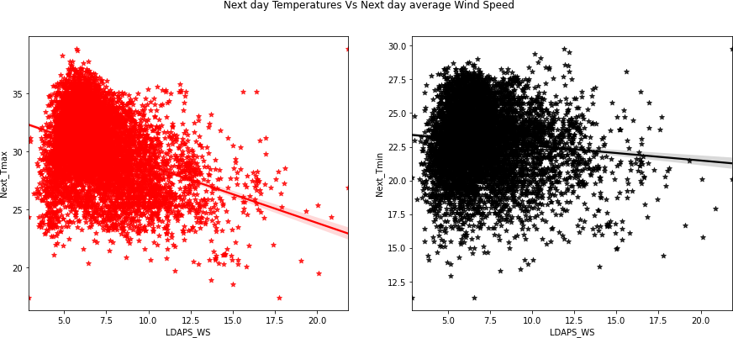

[45]:

Temperarue decreases as the wind speed increases. Tmax seem to decrease more drastically than Tmin

1. : <AxesSubplot:xlabel='LDAPS_LH', ylabel='Next_Tmin'>

plt.figure(figsize=(15,6))

plt.suptitle('Next day Temperatures Vs Next day average latent heat flux')

plt.subplot(1,2,1) sns.regplot(x='LDAPS_LH',y='Next_Tmax',data=df,marker='*',color='g')

plt.subplot(1,2,2) sns.regplot(x='LDAPS_LH',y='Next_Tmin',data=df,marker='*',color='b')

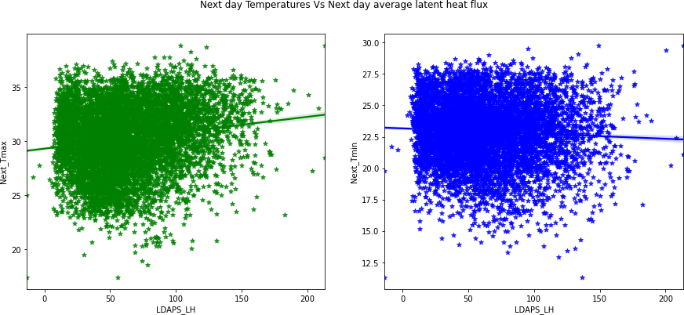

[46]:

As Latent heat flux increases Tmax also increases while Tmin decreases. Latent heat flux seem to bring out extremes of temperature with its increase.

1. : <AxesSubplot:xlabel='Solar radiation', ylabel='Next_Tmin'>

plt.figure(figsize=(15,6))

plt.suptitle('Next day Temperatures Vs Daily incoming solar radiation')

plt.subplot(1,2,1)

sns.regplot(x='Solar radiation',y='Next_Tmax',data=df,marker='*',color='y')

plt.subplot(1,2,2)

sns.regplot(x='Solar radiation',y='Next_Tmin',data=df,marker='*',color='k')

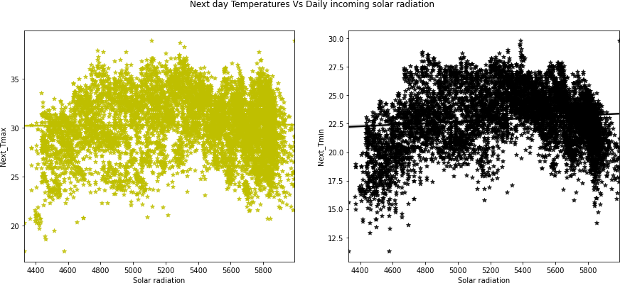

[47]:

Solar radiation does not seem to affect Tmax or Tmin even though studies have shown that Air temperatures have their origin in the absorption of radiant energy from the Sun.

1. : <AxesSubplot:xlabel='LDAPS_CC4', ylabel='Next_Tmax'>

plt.figure(figsize=(15,12))

plt.suptitle('Next day Maximum Temperature Vs Next day average Cloud Cover')

plt.subplot(2,2,1) sns.regplot(x='LDAPS_CC1',y='Next_Tmax',data=df,marker='*',color='r')

plt.subplot(2,2,2) sns.regplot(x='LDAPS_CC2',y='Next_Tmax',data=df,marker='*',color='b')

plt.subplot(2,2,3) sns.regplot(x='LDAPS_CC3',y='Next_Tmax',data=df,marker='*',color='g')

plt.subplot(2,2,4) sns.regplot(x='LDAPS_CC4',y='Next_Tmax',data=df,marker='*',color='k')

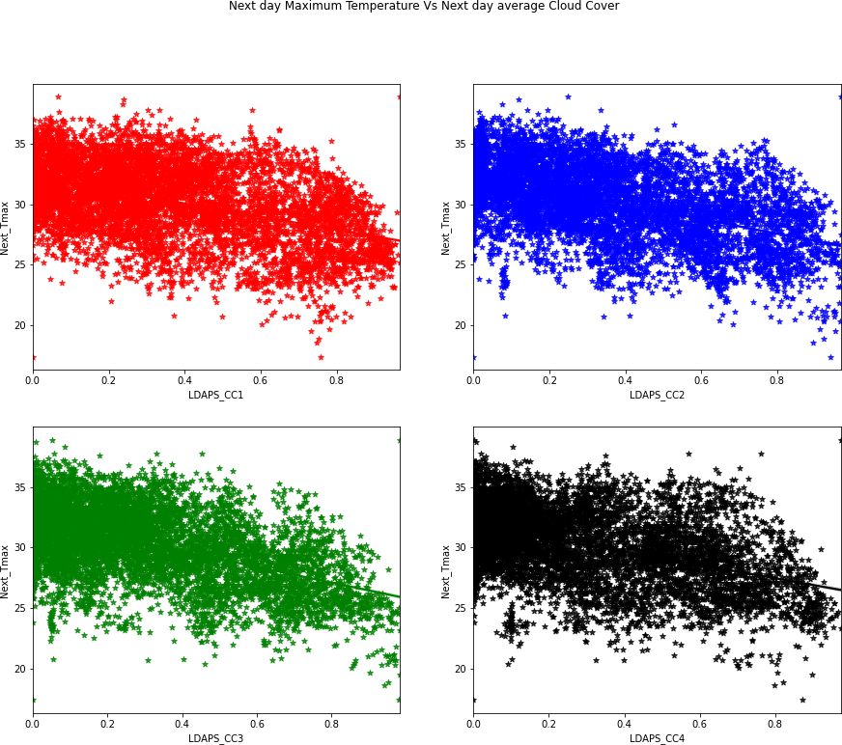

[48]:

plt.figure(figsize=(15,12))

plt.suptitle('Next day Minimum Temperature Vs Next day average Cloud Cover')

plt.subplot(2,2,1) sns.regplot(x='LDAPS_CC1',y='Next_Tmin',data=df,marker='*',color='b')

plt.subplot(2,2,2) sns.regplot(x='LDAPS_CC2',y='Next_Tmin',data=df,marker='*',color='k')

plt.subplot(2,2,3) sns.regplot(x='LDAPS_CC3',y='Next_Tmin',data=df,marker='*',color='r')

plt.subplot(2,2,4) sns.regplot(x='LDAPS_CC4',y='Next_Tmin',data=df,marker='*',color='g')

Tmax decreases as the cloud cover increases irrespective of any split which is also what studies show.

1. : <AxesSubplot:xlabel='LDAPS_CC4', ylabel='Next_Tmin'>

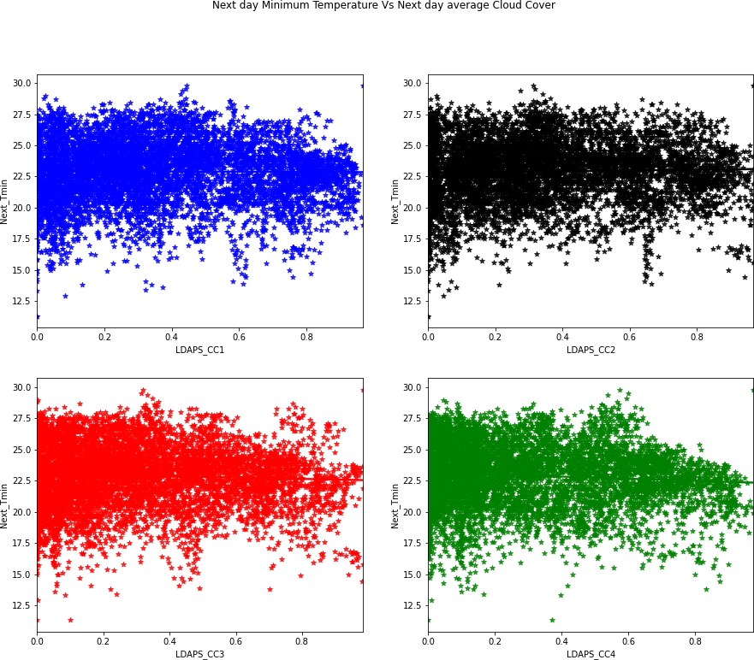

[49]:

plt.figure(figsize=(15,12))

plt.suptitle('Next day Maximum Temperature Vs Next day average Precipitation')

plt.subplot(2,2,1) sns.regplot(x='LDAPS_PPT1',y='Next_Tmax',data=df,marker='*',color='r')

plt.subplot(2,2,2) sns.regplot(x='LDAPS_PPT2',y='Next_Tmax',data=df,marker='*',color='b')

plt.subplot(2,2,3) sns.regplot(x='LDAPS_PPT3',y='Next_Tmax',data=df,marker='*',color='g')

Tmin seems to remain unaffeact by cloud cover as cloud cover is also responsible for green house effect which increases the temperature.

plt.subplot(2,2,4) sns.regplot(x='LDAPS_PPT4',y='Next_Tmax',data=df,marker='*',color='y')

1. : <AxesSubplot:xlabel='LDAPS_PPT4', ylabel='Next_Tmax'>

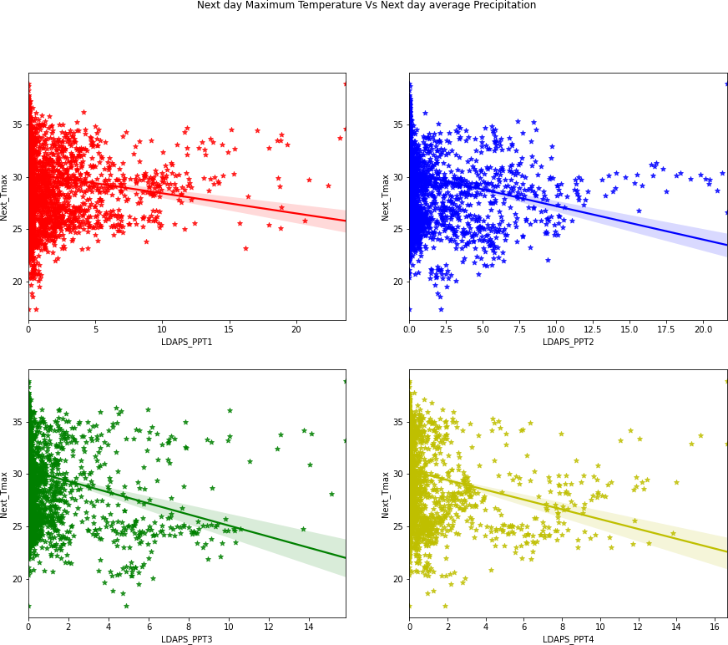

[50]:

plt.figure(figsize=(15,12))

plt.suptitle('Next day Minimum Temperature Vs Next day average Precipitation')

plt.subplot(2,2,1) sns.regplot(x='LDAPS_PPT1',y='Next_Tmin',data=df,marker='*',color='b')

plt.subplot(2,2,2) sns.regplot(x='LDAPS_PPT2',y='Next_Tmin',data=df,marker='*',color='k')

Tmax decreases as the precipitation increases irrespective of any split which is also what studies show

plt.subplot(2,2,3) sns.regplot(x='LDAPS_PPT3',y='Next_Tmin',data=df,marker='*',color='r')

plt.subplot(2,2,4) sns.regplot(x='LDAPS_PPT4',y='Next_Tmin',data=df,marker='*',color='y')

1. : <AxesSubplot:xlabel='LDAPS_PPT4', ylabel='Next_Tmin'>

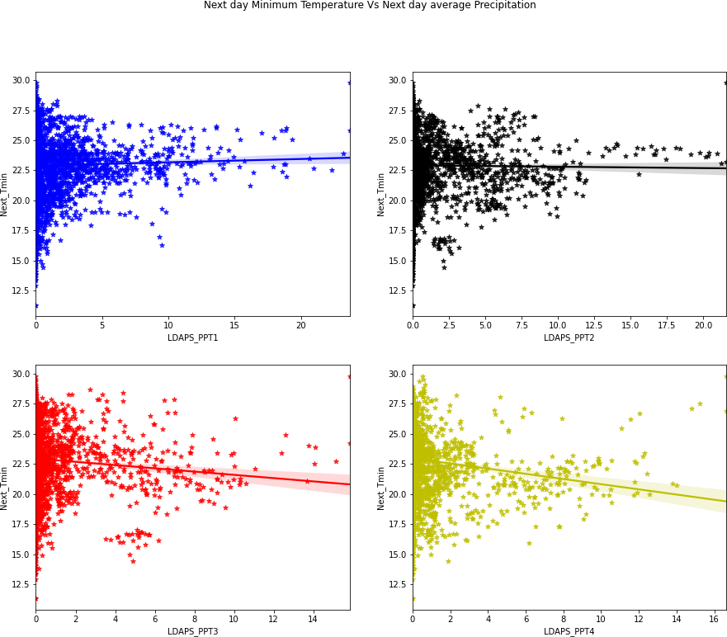

[51]:

There is very slight hange on increase of precipitation in Tmin. Tmin seem to decrease slightly as the precipitation increases with later splits.

### Multivariate Analysis

plt.figure(figsize=(15,15)) plt.subplot(2,1,1)

sns.stripplot(x='station',y='Next_Tmax',hue='lat',data=df)

plt.subplot(2,1,2) sns.stripplot(x='station',y='Next_Tmin',hue='lat',data=df)

1. : <AxesSubplot:xlabel='station', ylabel='Next_Tmin'>

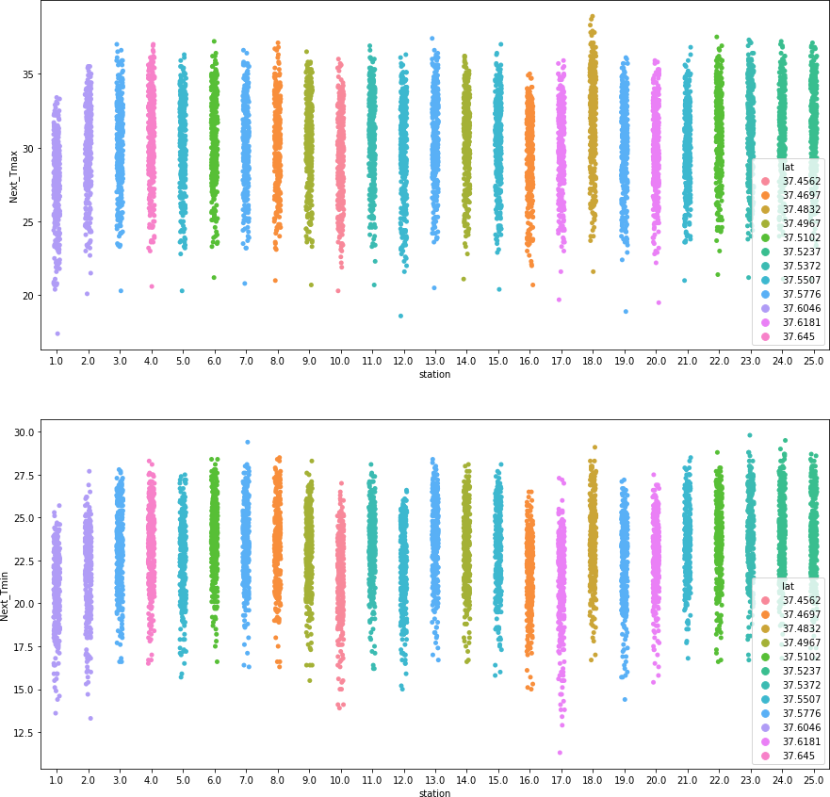

[52]:

plt.figure(figsize=(15,15)) plt.subplot(2,1,1)

sns.stripplot(x='station',y='Next_Tmax',hue='lon',data=df) plt.legend('')

plt.subplot(2,1,2)

Each station is located on a particular latitude, There are at most 3 stations on a single latitude, and as the latitude decreases, temperature seem to increase.

sns.stripplot(x='station',y='Next_Tmin',hue='lon',data=df)

1. : <AxesSubplot:xlabel='station', ylabel='Next_Tmin'>

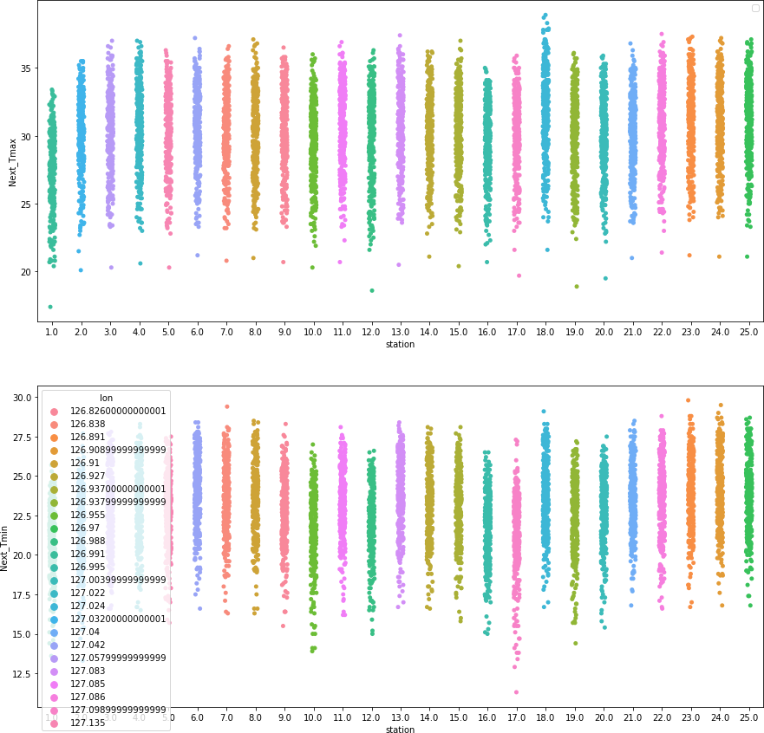

[53]:

plt.figure(figsize=(15,15)) plt.subplot(2,1,1)

sns.stripplot(x='station',y='Next_Tmax',hue='DEM',data=df) plt.legend('')

plt.subplot(2,1,2)

Each station belongs to a particular longitude. There is only one station belonging to a longitude. As the longitude do not affect the temperatures much the graphs are similar to the station vs latitudes.

sns.stripplot(x='station',y='Next_Tmin',hue='DEM',data=df)

1. : <AxesSubplot:xlabel='station', ylabel='Next_Tmin'>

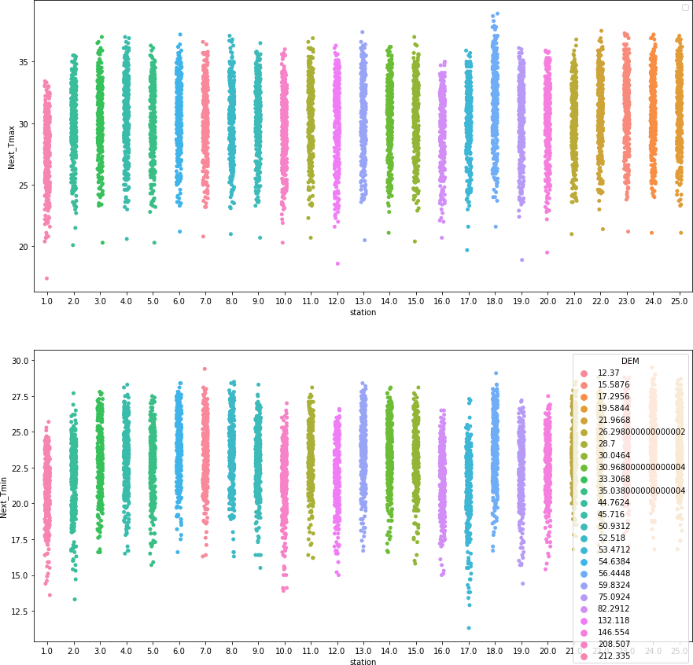

[54]:

plt.figure(figsize=(15,12))

plt.subplot(2,2,1) sns.scatterplot(x='LDAPS_PPT1',y='LDAPS_CC1',hue='Next_Tmax',data=df)

plt.subplot(2,2,2)

Each station belong to a particular elevation. There is only one station belonging to a particular elevation. Highest tmax is noted at station 18 which have an elevation 56.44 even though it is not the lowest elevation, which indicates that elevation alone does not decide the temperature.

sns.scatterplot(x='LDAPS_PPT2',y='LDAPS_CC2',hue='Next_Tmax',data=df)

plt.subplot(2,2,3) sns.scatterplot(x='LDAPS_PPT3',y='LDAPS_CC3',hue='Next_Tmax',data=df)

plt.subplot(2,2,4) sns.scatterplot(x='LDAPS_PPT4',y='LDAPS_CC4',hue='Next_Tmax',data=df)

1. : <AxesSubplot:xlabel='LDAPS_PPT4', ylabel='LDAPS_CC4'>

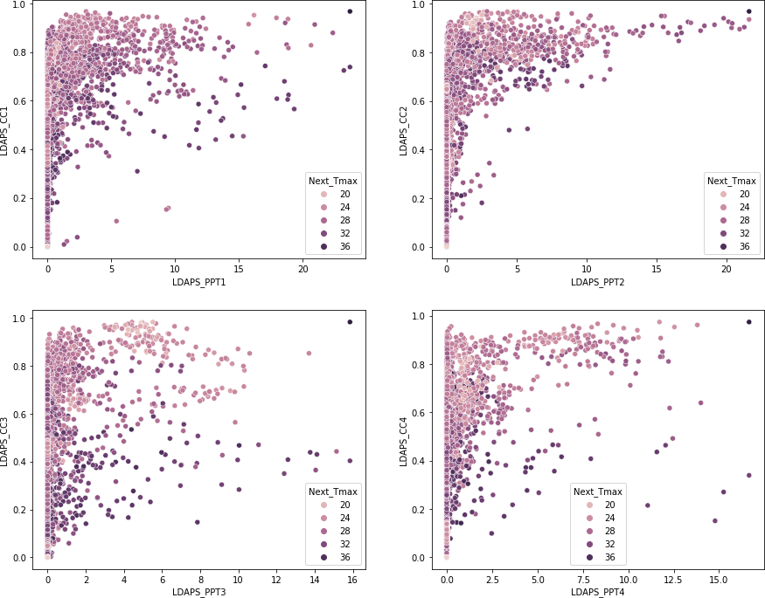

plt.figure(figsize=(15,12))

plt.subplot(2,2,1) sns.scatterplot(x='LDAPS_PPT1',y='LDAPS_CC1',hue='Next_Tmin',data=df)

[55]:

In the 1st split of cloud cover and precipitation, precipitation increases after a value of cloud cover crosses 0.3 while this threshold increases to 0.5 in 2nd split after that decreases for all the splits. Tmax is higher when their cloud cover and precipitation both have lower value, while presence of outliers are also there.

plt.subplot(2,2,2) sns.scatterplot(x='LDAPS_PPT2',y='LDAPS_CC2',hue='Next_Tmin',data=df)

plt.subplot(2,2,3) sns.scatterplot(x='LDAPS_PPT3',y='LDAPS_CC3',hue='Next_Tmin',data=df)

plt.subplot(2,2,4) sns.scatterplot(x='LDAPS_PPT4',y='LDAPS_CC4',hue='Next_Tmin',data=df)

1. : <AxesSubplot:xlabel='LDAPS_PPT4', ylabel='LDAPS_CC4'>

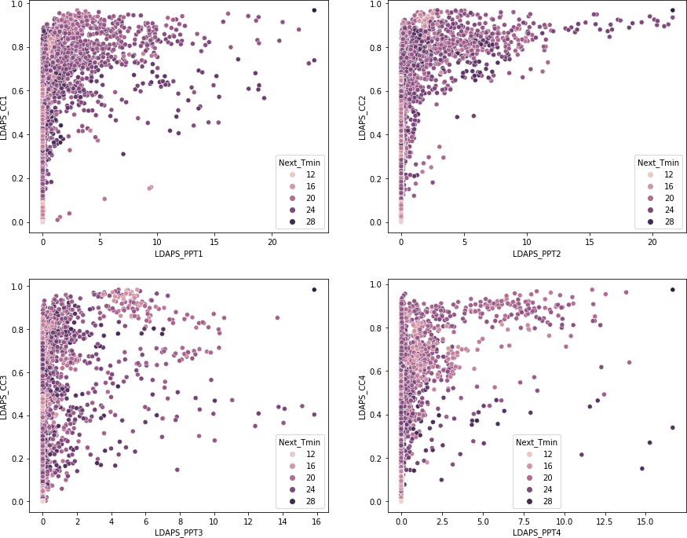

plt.figure(figsize=(15,8))

plt.subplot(1,2,1) sns.scatterplot(x='LDAPS_RHmax',y='LDAPS_Tmax_lapse',hue='Next_Tmax',data=df)

[56]:

In the 1st split of cloud cover and precipitation, precipitation increases after a value of cloud cover crosses 0.3 while this threshold increases to 0.5 in 2nd split after that decreases for all the splits. Tmin is higher when their cloud cover and precipitation both have lower value.

plt.subplot(1,2,2) sns.scatterplot(x='LDAPS_RHmin',y='LDAPS_Tmin_lapse',hue='Next_Tmax',data=df)

1. : <AxesSubplot:xlabel='LDAPS_RHmin', ylabel='LDAPS_Tmin_lapse'>

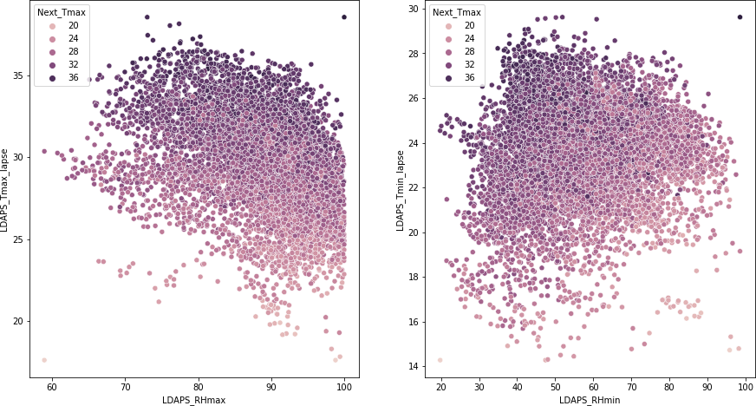

[57]:

As RHmax increases, Tmax lapse rate decreases and Next day Tmax also seem to decrease while as Rhmin increases Tmin lapse rate also seem to increase but Next dat Tmax decreases

1. : <AxesSubplot:xlabel='LDAPS_RHmin', ylabel='LDAPS_Tmin_lapse'>

plt.figure(figsize=(15,8))

plt.subplot(1,2,1) sns.scatterplot(x='LDAPS_RHmax',y='LDAPS_Tmax_lapse',hue='Next_Tmin',data=df)

plt.subplot(1,2,2) sns.scatterplot(x='LDAPS_RHmin',y='LDAPS_Tmin_lapse',hue='Next_Tmin',data=df)

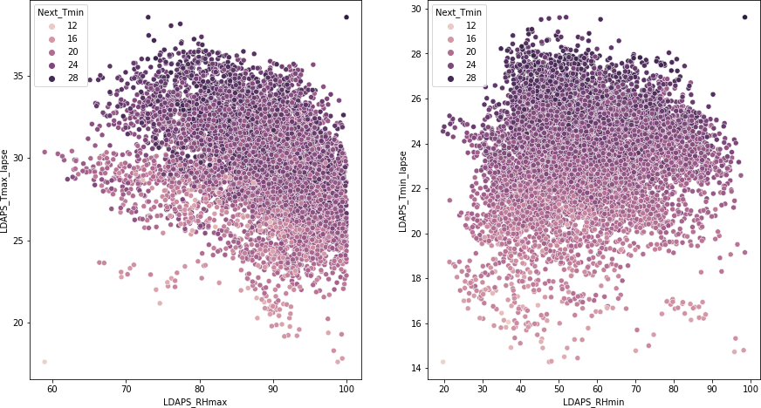

[58]:

As RHmax increases, Tmax lapse rate decreases and Next day Tmin also seem to decrease while as Rhmin increases Tmin lapse rate also seem to increase but Next dat Tmin decreases

1. : <AxesSubplot:>

plt.figure(figsize=(20,15)) sns.heatmap(df.corr(),annot=**True**,cmap='Greys')

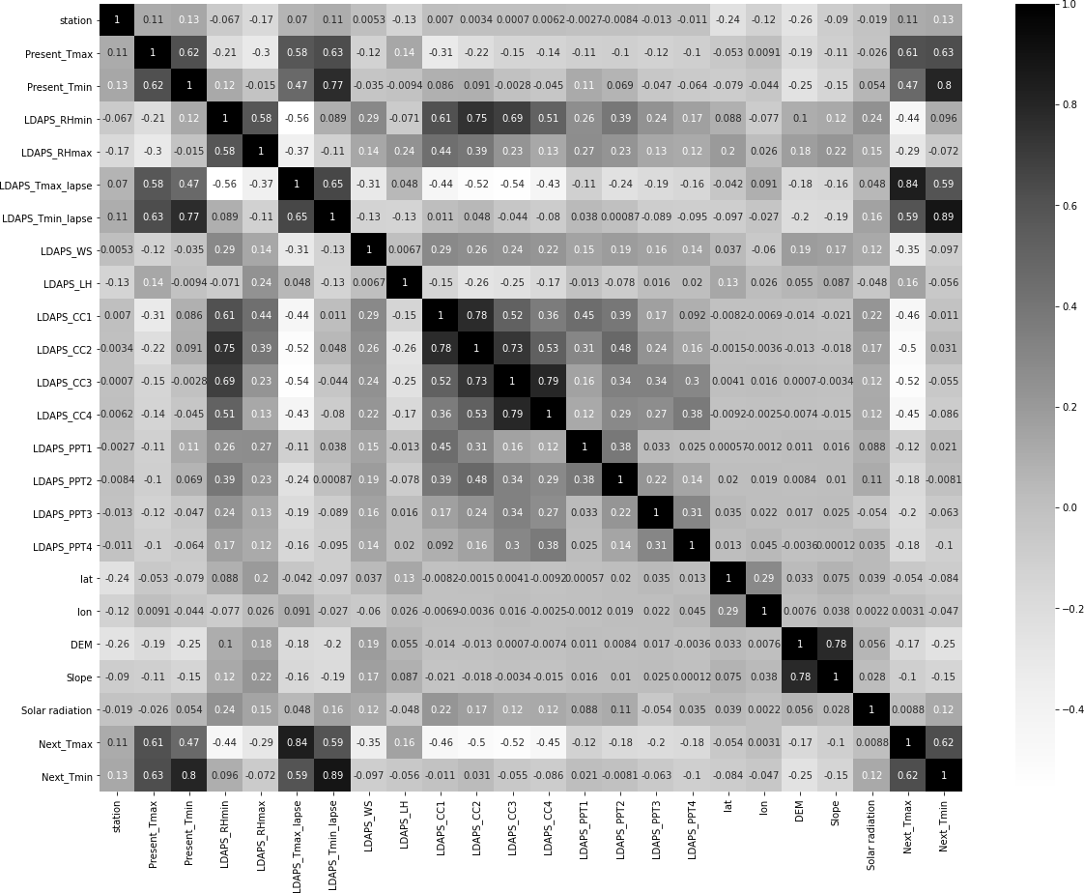

[59]:

[60]:

|  |  |  |  |  |  |  |
| --- | --- | --- | --- | --- | --- | --- |
| [60]: array([2.785 | , 0.5141 | , 0.2661 | , 2.5348 | , 0.5055 | , 0.1457 | , |
| 0.0985 | , 1.5629 | , 0.4125 | , 5.1782 | , 0.6233 | , 0.5931 | , |
| 2.6865 | , 0.618 | , 0.8552 | , 2.2579 | , 0.697 | , 1.2313 | , |
| 1.7678 | , 4.7296 | , 0.5721 | , 0.1332 | , 0.1554 | , 0.2223 | , |

There is high correlation of Next day Tmax and Tmin with Present day Tmax and Tmin, Tmax applied lapse rate and Tmin applied lapse rate. There is also a high negative correlation of Tmax with cloud cover splits and relative minimum humidity. There is also high correlation between many independent features such as Present Day Tmax and Tmin, elevation and slope etc. Multicollinearity need to be eliminated.

# Pre-Processing Pipeline

### Dropping Date Column Rounding off the value of slope

df.drop('Date',axis=1,inplace=**True**)

df['Slope'].unique()

[63]:

0.2713 , 0.0984746, 5.17823 ])

As seen in EDA process 0.0984746 need to be rounded as 0.0985 and 5.17823 need to be rounded as 5.1782

df['Slope'].replace({0.09847460000000001:0.0985,5.17823:5.1782,0.

*‹→*6970000000000001:0.6970},inplace=**True**)

[64]:

plt.figure(figsize=(20,5)) sns.countplot(df['Slope']) plt.xticks(rotation=45)

[64]: (array([ 0, 1, 2, 3, 4, 5, 6, 7, 8, 9, 10, 11, 12, 13, 14, 15, 16,

17, 18, 19, 20, 21, 22, 23, 24]),

|  |  |  |
| --- | --- | --- |
| [Text(0, | 0, | '0.0985'), |
| Text(1, | 0, | '0.1332'), |
| Text(2, | 0, | '0.1457'), |
| Text(3, | 0, | '0.1554'), |
| Text(4, | 0, | '0.2223'), |
| Text(5, | 0, | '0.2661'), |
| Text(6, | 0, | '0.2713'), |
| Text(7, | 0, | '0.4125'), |
| Text(8, | 0, | '0.5055'), |
| Text(9, | 0, | '0.5141'), |
| Text(10, | 0, | '0.5721'), |
| Text(11, | 0, | '0.5931'), |
| Text(12, | 0, | '0.618'), |
| Text(13, | 0, | '0.6233'), |
| Text(14, | 0, | '0.697'), |
| Text(15, | 0, | '0.8552'), |
| Text(16, | 0, | '1.2313'), |
| Text(17, | 0, | '1.5629'), |
| Text(18, | 0, | '1.7678'), |
| Text(19, | 0, | '2.2579'), |
| Text(20, | 0, | '2.5348'), |
| Text(21, | 0, | '2.6865'), |
| Text(22, | 0, | '2.785'), |
| Text(23, | 0, | '4.7296'), |
| Text(24, | 0, | '5.1782')]) |

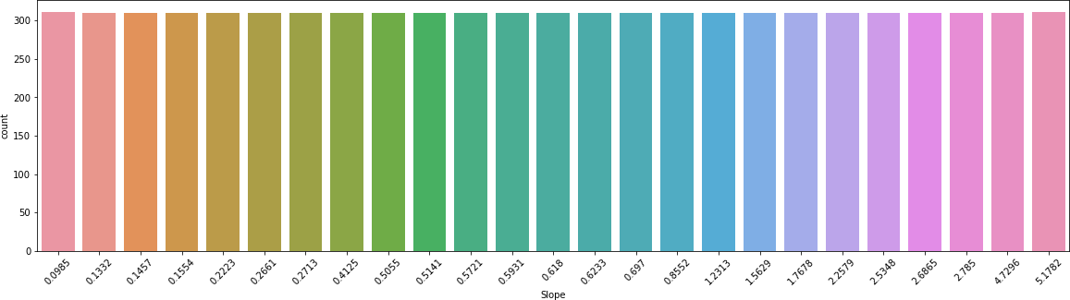

[65]:

[66]:

Now there are no ambiguous values

### Imputing Null values

**from scipy.stats import** mode

**Next Tmax and Tmin columns**

*#We need to drop these rows as these are the label columns cannot impute null*␣

*‹→values to these*

df=df[df['Next_Tmax'].notnull()]

[67]:

table=pd.pivot_table(values='station',index='Slope',data=df) table.head()

### Station column

|  |  |  |
| --- | --- | --- |
| [67]: | Slope | station |
|  | 0.0985 | 7.0 |
|  | 0.1332 | 22.0 |
|  | 0.1457 | 6.0 |
|  | 0.1554 | 23.0 |
|  | 0.2223 | 24.0 |

Filling nan values of station from slope column as slope serves as an identifier column to station.

[68]:

**def** sta(x):

**return** table.loc[x['Slope'],'station']

df['station'].fillna(df[df['station'].isnull()].apply(sta,axis=1),inplace=**True**)

[69]:

df.dropna(subset=df.columns, thresh=14,inplace=**True**)

[70]:

*#We are dropping these null values as weel because upon evalution this gives*␣

*‹→better result than imputing these with mean values*

### Deleting rows which have atleast 14 null values Present Tmax and Tmin

df.dropna(inplace=**True**)

[71]:

sns.heatmap(df.isnull())

[71]: <AxesSubplot:>

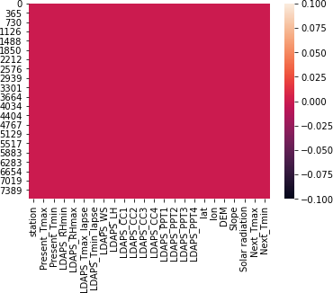

[72]:

No Null values remain

### Removing Outliers

*#Using zscore method to remove outliers*

**from scipy.stats import** zscore

[73]:

*#Function to choose the right threshold*

**def** threhold(z,d):

**for** i **in** np.arange(3,5,0.2): data=d.copy() data=data[(z<i).all(axis=1)]

loss=(d.shape[0]-data.shape[0])/d.shape[0]*100



print('With threshold **{}** data loss is **{}** '.format(np.round(i,1),np.

*‹→*round(loss,2)))

[74]:

z=np.abs(zscore(df)) threhold(z,df)

|  |  |  |  |  |  |  |
| --- | --- | --- | --- | --- | --- | --- |
| With | threshold | 3.0 | data | loss | is | 11.09 |
| With | threshold | 3.2 | data | loss | is | 9.51 |
| With | threshold | 3.4 | data | loss | is | 8.38 |
| With | threshold | 3.6 | data | loss | is | 7.56 |
| With | threshold | 3.8 | data | loss | is | 6.89 |
| With | threshold | 4.0 | data | loss | is | 6.25 |
| With | threshold | 4.2 | data | loss | is | 5.8 |
| With | threshold | 4.4 | data | loss | is | 5.19 |
| With | threshold | 4.6 | data | loss | is | 4.74 |
| With | threshold | 4.8 | data | loss | is | 4.37 |

[75]:

*#We use threshold as 4.2 because data is expensive and upon evaluation of*␣

*‹→models this threhold turned out to be the best.*

df=df[(z<4.2).all(axis=1)]

### Removing Skewness

[76]:

**from sklearn.preprocessing import** PowerTransformer pt=PowerTransformer()

[77]:

**for** i **in** cont:

**if** np.abs(df[i].skew())>=0.5: df[i]=pt.fit_transform(df[i].values.reshape(-1,1))

[78]:



fig,ax=plt.subplots(9,2,figsize=(15,55)) r=0

c=0

**for** i, n **in** enumerate(cont[:-2]):

**if** i **2**==0 and i>0: r+=1

c=0 sns.distplot(df[n],color='r',ax=ax[r,c]) c+=1

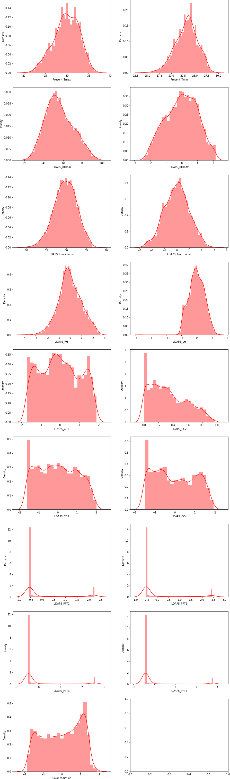

54

Skewness is reduced considerably

[79]:

*#Separating dependent and independent features.* x=df.copy() x.drop(['Next_Tmax','Next_Tmin'],axis=1,inplace=**True**) ymax=df['Next_Tmax']

ymin=df['Next_Tmin']

### Scaling the dataset

[80]:

*#Scaling the data using min max scaler*

**from sklearn.preprocessing import** MinMaxScaler scaler=MinMaxScaler()

[81]:

xd=scaler.fit_transform(x) x=pd.DataFrame(xd,columns=x.columns)

# Building Machine Learning Models

[82]:

**from sklearn.model_selection import** train_test_split,cross_val_score

[83]:

*#importing models*

**from sklearn.neighbors import** KNeighborsRegressor

**from sklearn.linear_model import** LinearRegression,Lasso,Ridge,ElasticNet

**from sklearn.svm import** SVR

**from sklearn.tree import** DecisionTreeRegressor

**from sklearn.ensemble import**␣

*‹→*RandomForestRegressor,AdaBoostRegressor,GradientBoostingRegressor

**from xgboost import** XGBRegressor

[84]:

**from sklearn.metrics import** r2_score,mean_absolute_error,mean_squared_error

[85]:

*#Choosing the best random state using Logistic regression*

**def** randomstate(a,b): maxx=10000000000000

**for** state **in** range(1,201): xtrain,xtest,ytrain,ytest=train_test_split(a,b,test_size=0.

*‹→*25,random_state=state)

model=LinearRegression() model.fit(xtrain,ytrain) p=model.predict(xtest) mse=mean_squared_error(p,ytest) **if** maxx>mse:

maxx=mse

j=state

**return** j

[87]: *#Creating list of models and another list mapped to their names*

models=[KNeighborsRegressor(),SVR(),LinearRegression(),Lasso(),Ridge(),DecisionTreeRegressor()

␣

*‹→*RandomForestRegressor(),AdaBoostRegressor(),GradientBoostingRegressor(),XGBRegressor()]

names=['KNeighborsRegressor','SVR','LinearRegression','Lasso','Ridge','DecisionTreeRegressor',

␣

*‹→*'RandomForestRegressor','AdaBoostRegressor','GradientBoostingRegressor','XGBRegressor']

[88]:

**def** createmodels(model_list,x,y,n): name=[]

meanabs=[] meansqd=[] rootmeansqd=[] r2=[]

mcv=[]

xtrain,xtest,ytrain,ytest=train_test_split(x,y,test_size=0.

*‹→*25,random_state=randomstate(x,y))

*#Creating models*

**for** i,model **in** enumerate(model_list): model.fit(xtrain,ytrain) p=model.predict(xtest) score=cross_val_score(model,x,y,cv=5)

*#Calculating scores of the model and appending them to a list* name.append(n[i]) meanabs.append(np.round(mean_absolute_error(p,ytest),4)) meansqd.append(np.round(mean_squared_error(p,ytest),4)) rootmeansqd.append(np.round(np.sqrt(mean_squared_error(p,ytest)),4)) r2.append(np.round(r2_score(p,ytest),2)*100) mcv.append(np.round(np.mean(score),2)*100)

*#Creating Dataframe* data=pd.DataFrame() data['Model']=name

data['Mean Absolute Error']=meanabs data['Mean Squared Error']=meansqd data['Root Mean Squared Error']=rootmeansqd data['R2 Score']=r2

data['Mean of Cross Validation Score']=mcv data.set_index('Model',inplace = **True**) **return** data

[89]:

createmodels(models,x,ymax,names)

|  |  |  |  |  |  |  |  |
| --- | --- | --- | --- | --- | --- | --- | --- |
| [89]: | Model | Mean | Absolute Error | Mean | | Squared Error | \ |
|  | KNeighborsRegressor |  | 1.0486 |  | | 1.9802 |  |
|  | SVR |  | 0.8697 |  | | 1.4167 |  |
|  | LinearRegression |  | 1.0466 |  | | 1.9357 |  |
|  | Lasso |  | 2.4591 |  | | 9.0494 |  |
|  | Ridge |  | 1.0470 |  | | 1.9379 |  |
|  | DecisionTreeRegressor |  | 1.1183 |  | | 2.4360 |  |
|  | RandomForestRegressor |  | 0.7300 |  | | 0.9447 |  |
|  | AdaBoostRegressor |  | 1.1695 |  | | 2.1360 |  |
|  | GradientBoostingRegressor |  | 0.8873 |  | | 1.3530 |  |
|  | XGBRegressor |  | 0.6716 |  | | 0.7916 |  |
| Model | | Root | Mean Squared Error | | R2 Score | | \ |
| KNeighborsRegressor | |  | 1.4072 | | 7.000000e+01 | |  |
| SVR | |  | 1.1903 | | 8.000000e+01 | |  |
| LinearRegression | |  | 1.3913 | | 7.200000e+01 | |  |
| Lasso | |  | 3.0082 | | -1.792426e+31 | |  |
| Ridge | |  | 1.3921 | | 7.200000e+01 | |  |
| DecisionTreeRegressor | |  | 1.5608 | | 7.300000e+01 | |  |
| RandomForestRegressor | |  | 0.9719 | | 8.700000e+01 | |  |
| AdaBoostRegressor | |  | 1.4615 | | 6.100000e+01 | |  |
| GradientBoostingRegressor | |  | 1.1632 | | 8.100000e+01 | |  |
| XGBRegressor | |  | 0.8897 | | 9.000000e+01 | |  |
| Model | | Mean | of Cross Validation Score | | | | |
| KNeighborsRegressor | |  | 46.0 | | | | |
| SVR | |  | 65.0 | | | | |
| LinearRegression | |  | 70.0 | | | | |
| Lasso | |  | -7.0 | | | | |
| Ridge | |  | 70.0 | | | | |
| DecisionTreeRegressor | |  | 45.0 | | | | |
| RandomForestRegressor | |  | 68.0 | | | | |
| AdaBoostRegressor | |  | 66.0 | | | | |
| GradientBoostingRegressor | |  | 70.0 | | | | |
| XGBRegressor | |  | 65.0 | | | | |

[90]:

createmodels(models,x,ymin,names)

For predicting Next day Maximum Temperature Random Forest, Xtreme Gradient Boost give the least error value while Ridge regressor is giving the highest mean of cross validation score along with Gradient Boosting Model.

|  |  |  |  |  |  |  |  |
| --- | --- | --- | --- | --- | --- | --- | --- |
| [90]: | Model | Mean | Absolute Error | Mean | | Squared Error | \ |
|  | KNeighborsRegressor |  | 0.8176 |  | | 1.1781 |  |
|  | SVR |  | 0.6259 |  | | 0.6434 |  |
|  | LinearRegression |  | 0.7751 |  | | 0.9477 |  |
|  | Lasso |  | 1.9866 |  | | 6.1585 |  |
|  | Ridge |  | 0.7752 |  | | 0.9478 |  |
|  | DecisionTreeRegressor |  | 0.8625 |  | | 1.3753 |  |
|  | RandomForestRegressor |  | 0.5763 |  | | 0.5646 |  |
|  | AdaBoostRegressor |  | 0.8625 |  | | 1.1351 |  |
|  | GradientBoostingRegressor |  | 0.6446 |  | | 0.6659 |  |
|  | XGBRegressor |  | 0.4880 |  | | 0.4026 |  |
| Model | | Root | Mean Squared Error | | R2 Score | | \ |
| KNeighborsRegressor | |  | 1.0854 | | 7.200000e+01 | |  |
| SVR | |  | 0.8021 | | 8.700000e+01 | |  |
| LinearRegression | |  | 0.9735 | | 8.200000e+01 | |  |
| Lasso | |  | 2.4816 | | -4.879260e+31 | |  |
| Ridge | |  | 0.9736 | | 8.100000e+01 | |  |
| DecisionTreeRegressor | |  | 1.1727 | | 7.800000e+01 | |  |
| RandomForestRegressor | |  | 0.7514 | | 8.900000e+01 | |  |
| AdaBoostRegressor | |  | 1.0654 | | 7.600000e+01 | |  |
| GradientBoostingRegressor | |  | 0.8160 | | 8.700000e+01 | |  |
| XGBRegressor | |  | 0.6345 | | 9.300000e+01 | |  |

Model

Mean of Cross Validation Score

[91]:

KNeighborsRegressor 47.0

SVR 75.0

LinearRegression 78.0

Lasso -14.0

Ridge 78.0

DecisionTreeRegressor 57.0

RandomForestRegressor 78.0

AdaBoostRegressor 75.0

GradientBoostingRegressor 80.0

XGBRegressor 77.0

Same is the case while prediction Next day minimum temperature as Random Forest, Xtreme Gradient Boost give the least error value while Gradient Boost is giving the highest mean of cross validation score.

### 4.0.1 Reducing Multicollinearity using Lasso For Tmax

**from sklearn.model_selection import** GridSearchCV

[92]:

param_grid={'alpha':[1e-15,1e-10,1e-8,1e-5,1e-3,0.

*‹→*1,1,5,10,15,20,30,35,45,50,55,65,100,110,150,1000]}

m1=GridSearchCV(Lasso(),param_grid,scoring='neg_mean_squared_error',cv=10) m1.fit(x,ymax)

print(m1.best_params_)

{'alpha': 0.001}

[93]:

m1=Lasso(alpha=0.001) m1.fit(x,ymax)

[93]: Lasso(alpha=0.001)

[94]:

importance = np.abs(m1.coef_)

[95]:

dfcolumns = pd.DataFrame(x.columns) dfimp=pd.DataFrame(importance)

featureScores = pd.concat([dfcolumns,dfimp],axis=1)

featureScores.columns = ['Features','Coefficients'] *#naming the dataframe*␣

*‹→columns*

featureScores

|  |  |  |  |
| --- | --- | --- | --- |
| [95]: |  | Features | Coefficients |
|  | 0 | station | 0.414667 |
|  | 1 | Present_Tmax | 2.892366 |
|  | 2 | Present_Tmin | 0.439141 |
|  | 3 | LDAPS_RHmin | 1.867211 |
|  | 4 | LDAPS_RHmax | 0.033401 |
|  | 5 | LDAPS_Tmax_lapse | 12.237564 |
|  | 6 | LDAPS_Tmin_lapse | 1.275452 |
|  | 7 | LDAPS_WS | 1.797137 |
|  | 8 | LDAPS_LH | 2.668634 |
|  | 9 | LDAPS_CC1 | 0.298872 |
|  | 10 | LDAPS_CC2 | 0.617885 |
|  | 11 | LDAPS_CC3 | 0.515565 |
|  | 12 | LDAPS_CC4 | 1.265517 |
|  | 13 | LDAPS_PPT1 | 0.512172 |
|  | 14 | LDAPS_PPT2 | 0.230607 |
|  | 15 | LDAPS_PPT3 | 0.142552 |
|  | 16 | LDAPS_PPT4 | 0.203693 |
|  | 17 | lat | 0.111839 |
|  | 18 | lon | 0.501058 |
|  | 19 | DEM | 0.732655 |
|  | 20 | Slope | 0.766948 |
|  | 21 | Solar radiation | 0.220732 |

None of the features coeﬀicients have been reduced to zero.

### For Tmin

[96]:

param_grid={'alpha':[1e-15,1e-10,1e-8,1e-5,1e-3,0.

*‹→*1,1,5,10,15,20,30,35,45,50,55,65,100,110,150,1000]}

m1=GridSearchCV(Lasso(),param_grid,scoring='neg_mean_squared_error',cv=10) m1.fit(x,ymin)

print(m1.best_params_)

{'alpha': 0.001}

[97]:

m1=Lasso(alpha=0.001) m1.fit(x,ymin)

[97]: Lasso(alpha=0.001)

[98]:

importance = np.abs(m1.coef_)

[99]:

dfcolumns = pd.DataFrame(x.columns) dfimp=pd.DataFrame(importance)

featureScores = pd.concat([dfcolumns,dfimp],axis=1)

featureScores.columns = ['Features','Coefficients'] *#naming the dataframe*␣

*‹→columns*

featureScores

|  |  |  |  |
| --- | --- | --- | --- |
| [99]: |  | Features | Coefficients |
|  | 0 | station | 0.000000 |
|  | 1 | Present_Tmax | 0.946818 |
|  | 2 | Present_Tmin | 3.799765 |
|  | 3 | LDAPS_RHmin | 1.725961 |
|  | 4 | LDAPS_RHmax | 0.567889 |
|  | 5 | LDAPS_Tmax_lapse | 2.436989 |
|  | 6 | LDAPS_Tmin_lapse | 8.335946 |
|  | 7 | LDAPS_WS | 0.608111 |
|  | 8 | LDAPS_LH | 0.228965 |
|  | 9 | LDAPS_CC1 | 0.000000 |
|  | 10 | LDAPS_CC2 | 0.383626 |
|  | 11 | LDAPS_CC3 | 0.017080 |
|  | 12 | LDAPS_CC4 | 0.057504 |
|  | 13 | LDAPS_PPT1 | 0.278733 |
|  | 14 | LDAPS_PPT2 | 0.458225 |
|  | 15 | LDAPS_PPT3 | 0.126994 |
|  | 16 | LDAPS_PPT4 | 0.306195 |
|  | 17 | lat | 0.162643 |
|  | 18 | lon | 0.172734 |
|  | 19 | DEM | 1.463062 |
|  | 20 | Slope | 1.039085 |
|  | 21 | Solar radiation | 0.090083 |

Station column’s coeﬀicient has been reduced to zero, so we drop this feature and then check the performances of our model.

[100]:

xlasso=x.drop('station',axis=1)

[101]:

createmodels(models,xlasso,ymin,names)

|  |  |  |  |  |  |  |  |
| --- | --- | --- | --- | --- | --- | --- | --- |
| [101]: | Model | Mean | Absolute Error | Mean | | Squared Error | \ |
|  | KNeighborsRegressor |  | 0.7216 |  | | 0.9345 |  |
|  | SVR |  | 0.6172 |  | | 0.6219 |  |
|  | LinearRegression |  | 0.7749 |  | | 0.9475 |  |
|  | Lasso |  | 1.9866 |  | | 6.1585 |  |
|  | Ridge |  | 0.7751 |  | | 0.9476 |  |
|  | DecisionTreeRegressor |  | 0.8384 |  | | 1.2971 |  |
|  | RandomForestRegressor |  | 0.5758 |  | | 0.5627 |  |
|  | AdaBoostRegressor |  | 0.8689 |  | | 1.1391 |  |
|  | GradientBoostingRegressor |  | 0.6433 |  | | 0.6566 |  |
|  | XGBRegressor |  | 0.4944 |  | | 0.4143 |  |
| Model | | Root | Mean Squared Error | | R2 Score | | \ |
| KNeighborsRegressor | |  | 0.9667 | | 7.900000e+01 | |  |
| SVR | |  | 0.7886 | | 8.800000e+01 | |  |
| LinearRegression | |  | 0.9734 | | 8.200000e+01 | |  |
| Lasso | |  | 2.4816 | | -4.879260e+31 | |  |
| Ridge | |  | 0.9735 | | 8.100000e+01 | |  |
| DecisionTreeRegressor | |  | 1.1389 | | 7.900000e+01 | |  |
| RandomForestRegressor | |  | 0.7501 | | 8.900000e+01 | |  |
| AdaBoostRegressor | |  | 1.0673 | | 7.500000e+01 | |  |
| GradientBoostingRegressor | |  | 0.8103 | | 8.700000e+01 | |  |
| XGBRegressor | |  | 0.6437 | | 9.300000e+01 | |  |

Model

Mean of Cross Validation Score

KNeighborsRegressor 46.0

SVR 75.0

LinearRegression 78.0

Lasso -14.0

Ridge 78.0

DecisionTreeRegressor 55.0

RandomForestRegressor 78.0

AdaBoostRegressor 74.0

GradientBoostingRegressor 80.0

XGBRegressor 78.0

Performances of models have increased; Errors have been reduced and mean cross validation score of XGBRegressor has increased. So we keep this dataset for predicting Next day minimum Temperature.

[102]:

* 1. **Hyperparameter Tuning**

### For Next day Maximum Temperature

xtrain_max,xtest_max,ytrain_max,ytest_max=train_test_split(x,ymax,test_size=0.

*‹→*25,random_state=randomstate(x,ymax))

* + 1. **Ridge Regressor**

[103]:

params={'alpha':[1e-15,1e-10,1e-8,1e-5,1e-3,0.

*‹→*1,1,5,10,15,20,30,35,45,50,55,65,100,110,150,200,

230, 250,265, 270, 275, 290, 300, 500,1000]}

g=GridSearchCV(Ridge(),params,cv=10) g.fit(xtrain_max,ytrain_max)

[103]: GridSearchCV(cv=10, estimator=Ridge(),

param_grid={'alpha': [1e-15, 1e-10, 1e-08, 1e-05, 0.001, 0.1, 1, 5,

10, 15, 20, 30, 35, 45, 50, 55, 65, 100, 110,

150, 200, 230, 250, 265, 270, 275, 290, 300,

500, 1000]})

[104]:

print(g.best_estimator_) print(g.best_params_) print(g.best_score_)

[105]:

Ridge(alpha=0.1)

{'alpha': 0.1}

0.7637525257964427

m=Ridge(alpha=0.1) m.fit(xtrain_max,ytrain_max) p=m.predict(xtest_max)

[106]:

score=cross_val_score(m,x,ymax,cv=10)

[107]:

print('Mean Absolute Error is',np.round(mean_absolute_error(p,ytest_max),4)) print('Mean Squared Error is',np.round(mean_squared_error(p,ytest_max),4)) print('Root Mean Squared Error is',np.round(np.

*‹→*sqrt(mean_squared_error(p,ytest_max)),4))

print('R2 Score is',np.round(r2_score(p,ytest_max),4)*100)

print('Mean of cross validaton Score is',np.round(np.mean(score)*100,4))

Mean Absolute Error is 1.0466 Mean Squared Error is 1.9358

Root Mean Squared Error is 1.3913 R2 Score is 72.11999999999999

Mean of cross validaton Score is 66.4305

### Random Forest

[108]:

**from sklearn.model_selection import** RandomizedSearchCV

[109]:

params={'n_estimators':[100,200, 300, 500], 'min_samples_split':[1,2,3,4], 'min_samples_leaf':[1,2,3,4], 'max_depth':[**None**,1,2,3,4,5,6,7,8,9,10,15]}

g=RandomizedSearchCV(RandomForestRegressor(),params,cv=10,n_jobs=-2) g.fit(xtrain_max,ytrain_max)

[109]: RandomizedSearchCV(cv=10, estimator=RandomForestRegressor(), n_jobs=-2,

param_distributions={'max_depth': [None, 1, 2, 3, 4, 5, 6, 7,

8, 9, 10, 15],

'min_samples_leaf': [1, 2, 3, 4],

'min_samples_split': [1, 2, 3, 4],

'n_estimators': [100, 200, 300, 500]})

[110]:

print(g.best_estimator_) print(g.best_params_) print(g.best_score_)

[111]:

RandomForestRegressor(min_samples_leaf=3, min_samples_split=4)

{'n_estimators': 100, 'min_samples_split': 4, 'min_samples_leaf': 3, 'max_depth': None}

0.8852156005203392

m=RandomForestRegressor(min_samples_leaf=3, min_samples_split=4) m.fit(xtrain_max,ytrain_max)

p=m.predict(xtest_max) score=cross_val_score(m,x,ymax,cv=10)

[112]:

print('Mean Absolute Error is',np.round(mean_absolute_error(p,ytest_max),4)) print('Mean Squared Error is',np.round(mean_squared_error(p,ytest_max),4)) print('Root Mean Squared Error is',np.round(np.

*‹→*sqrt(mean_squared_error(p,ytest_max)),4))

print('R2 Score is',np.round(r2_score(p,ytest_max),4)*100)

print('Mean of cross validaton Score is',np.round(np.mean(score)*100,4))

Mean Absolute Error is 0.7445 Mean Squared Error is 0.9785

Root Mean Squared Error is 0.9892 R2 Score is 86.71

Mean of cross validaton Score is 64.6498

### Graidient Boost

[113]:

params={'n_estimators':[100,200,300,400,500], 'learning_rate':[0.001,0.01,0.10,], 'subsample':[0.5,1], 'max_depth':[1,2,3,4,5,6,7,8,9,10]}

g=RandomizedSearchCV(GradientBoostingRegressor(),params,cv=10) g.fit(xtrain_max,ytrain_max)

[113]: RandomizedSearchCV(cv=10, estimator=GradientBoostingRegressor(),

param_distributions={'learning_rate': [0.001, 0.01, 0.1],

'max_depth': [1, 2, 3, 4, 5, 6, 7, 8, 9,

10],

'n_estimators': [100, 200, 300, 400,

500],

'subsample': [0.5, 1]})

[114]:

print(g.best_params_) print(g.best_estimator_) print(g.best_score_)

[115]:

{'subsample': 1, 'n_estimators': 400, 'max_depth': 7, 'learning_rate': 0.1} GradientBoostingRegressor(max_depth=7, n_estimators=400, subsample=1) 0.9185256152515837

[116]:

m=GradientBoostingRegressor(max_depth=7, n_estimators=400, subsample=1) m.fit(xtrain_max,ytrain_max)

p=m.predict(xtest_max) score=cross_val_score(m,x,ymax,cv=10)

print('Mean Absolute Error is',np.round(mean_absolute_error(p,ytest_max),4)) print('Mean Squared Error is',np.round(mean_squared_error(p,ytest_max),4)) print('Root Mean Squared Error is',np.round(np.

*‹→*sqrt(mean_squared_error(p,ytest_max)),4))

print('R2 Score is',np.round(r2_score(p,ytest_max),4)*100)

print('Mean of cross validaton Score is',np.round(np.mean(score)*100,4))

Mean Absolute Error is 0.6319 Mean Squared Error is 0.7121

Root Mean Squared Error is 0.8439 R2 Score is 91.06

Mean of cross validaton Score is 63.89

### Extreme Gradient Boost

[117]:

params={

"learning_rate"

: [0.001,0.05, 0.10 ] ,

"max_depth" : [ 5, 6, 8, 10, 12, 15,20,25,30],

"min_child_weight" : [ 1, 3, 5,10],

"gamma" : [ 0.0, 0.1, 0.2 , 0.3, 0.4,10],

"colsample_bytree" : [ 0.3, 0.4, 0.5 , 0.7 ]

}

g=RandomizedSearchCV(XGBRegressor(verbosity=0),params,cv=10,n_jobs=-2) g.fit(xtrain_max,ytrain_max)

[117]: RandomizedSearchCV(cv=10,

estimator=XGBRegressor(base_score=None, booster=None,

colsample_bylevel=None, colsample_bynode=None, colsample_bytree=None, gamma=None, gpu_id=None, importance_type='gain', interaction_constraints=None, learning_rate=None, max_delta_step=None, max_depth=None, min_child_weight=None, missing=nan, monotone_constraints=None, n_estimators=100,… num_parallel_tree=None, random_state=None, reg_alpha=None, reg_lambda=None, scale_pos_weight=None, subsample=None, tree_method=None, validate_parameters=None, verbosity=0),

[118]:

print(g.best_estimator_) print(g.best_params_) print(g.best_score_)

n_jobs=-2,

param_distributions={'colsample_bytree': [0.3, 0.4, 0.5,

0.7],

'gamma': [0.0, 0.1, 0.2, 0.3, 0.4, 10],

'learning_rate': [0.001, 0.05, 0.1],

'max_depth': [5, 6, 8, 10, 12, 15, 20,

25, 30],

'min_child_weight': [1, 3, 5, 10]})

XGBRegressor(base_score=0.5, booster='gbtree', colsample_bylevel=1, colsample_bynode=1, colsample_bytree=0.5, gamma=0.2, gpu_id=-1,

[119]:

importance_type='gain', interaction_constraints='', learning_rate=0.1, max_delta_step=0, max_depth=10, min_child_weight=5, missing=nan, monotone_constraints='()', n_estimators=100, n_jobs=4, num_parallel_tree=1, random_state=0, reg_alpha=0, reg_lambda=1, scale_pos_weight=1, subsample=1, tree_method='exact', validate_parameters=1, verbosity=0)

{'min_child_weight': 5, 'max_depth': 10, 'learning_rate': 0.1, 'gamma': 0.2,

'colsample_bytree': 0.5}

0.9179043417565163

m=XGBRegressor(colsample_bytree=0.5,gamma=0.2,learning_rate=0.1,max_depth=10,␣

*‹→*min_child_weight=5)

m.fit(xtrain_max,ytrain_max) p=m.predict(xtest_max) score=cross_val_score(m,x,ymax,cv=10)

[120]:

print('Mean Absolute Error is',np.round(mean_absolute_error(p,ytest_max),4)) print('Mean Squared Error is',np.round(mean_squared_error(p,ytest_max),4)) print('Root Mean Squared Error is',np.round(np.

*‹→*sqrt(mean_squared_error(p,ytest_max)),4))

print('R2 Score is',np.round(r2_score(p,ytest_max),4)*100)

print('Mean of cross validaton Score is',np.round(np.mean(score)*100,4))

Mean Absolute Error is 0.6297 Mean Squared Error is 0.6933

Root Mean Squared Error is 0.8326 R2 Score is 91.13

Mean of cross validaton Score is 65.3644

## Conclusion

Extreme Gradient Boost is giving the best performance with least mean absolute error, mean squared error, root mean squared error and highest mean cross validation r2 score after ridge. So we choose this model as our final model.

### For Next day Minimun Temperature

1. : xtrain_min,xtest_min,ytrain_min,ytest_min=train_test_split(xlasso,ymin,test_size=0.

*‹→*25,random_state=randomstate(xlasso,ymin))

### Random Forest

[122]:

params={'n_estimators':[100,200, 300, 500], 'min_samples_split':[1,2,3,4], 'min_samples_leaf':[1,2,3,4], 'max_depth':[**None**,1,2,3,4,5,6,7,8,9,10,15,20,25]}

g=RandomizedSearchCV(RandomForestRegressor(),params,cv=10,n_jobs=-2)

g.fit(xtrain_min,ytrain_min)

1. : RandomizedSearchCV(cv=10, estimator=RandomForestRegressor(), n_jobs=-2,

param_distributions={'max_depth': [None, 1, 2, 3, 4, 5, 6, 7,

8, 9, 10, 15, 20, 25],

'min_samples_leaf': [1, 2, 3, 4],

'min_samples_split': [1, 2, 3, 4],

'n_estimators': [100, 200, 300, 500]})

[123]:

print(g.best_params_) print(g.best_estimator_) print(g.best_score_)

[124]:

{'n_estimators': 100, 'min_samples_split': 4, 'min_samples_leaf': 1, 'max_depth': None}

RandomForestRegressor(min_samples_split=4) 0.8979586911124166

m=RandomForestRegressor(min_samples_split=4) m.fit(xtrain_min,ytrain_min) p=m.predict(xtest_min) score=cross_val_score(m,xlasso,ymin,cv=10)

[125]:

print('Mean Absolute Error is',np.round(mean_absolute_error(p,ytest_min),4)) print('Mean Squared Error is',np.round(mean_squared_error(p,ytest_min),4)) print('Root Mean Squared Error is',np.round(np.

*‹→*sqrt(mean_squared_error(p,ytest_min)),4))

print('R2 Score is',np.round(r2_score(p,ytest_min),4)*100)

print('Mean of cross validaton Score is',np.round(np.mean(score)*100,4))

[126]:

Mean Absolute Error is 0.5762 Mean Squared Error is 0.5621

Root Mean Squared Error is 0.7497 R2 Score is 89.24

Mean of cross validaton Score is 74.2301

### Graidient Boost

params={'n_estimators':[100,200,300,400,500], 'learning_rate':[0.001,0.01,0.10,], 'subsample':[0.5,1], 'max_depth':[1,2,3,4,5,6,7,8,9,10]}

g=RandomizedSearchCV(GradientBoostingRegressor(),params,cv=10) g.fit(xtrain_min,ytrain_min)

[126]: RandomizedSearchCV(cv=10, estimator=GradientBoostingRegressor(),

param_distributions={'learning_rate': [0.001, 0.01, 0.1],

'max_depth': [1, 2, 3, 4, 5, 6, 7, 8, 9,

10],

'n_estimators': [100, 200, 300, 400,

500],

'subsample': [0.5, 1]})

[127]:

print(g.best_params_) print(g.best_estimator_) print(g.best_score_)

[128]:

{'subsample': 0.5, 'n_estimators': 500, 'max_depth': 8, 'learning_rate': 0.1} GradientBoostingRegressor(max_depth=8, n_estimators=500, subsample=0.5) 0.9306608978906074

[129]:

m=GradientBoostingRegressor(max_depth=8, n_estimators=500, subsample=0.5) m.fit(xtrain_min,ytrain_min)

p=m.predict(xtest_min) score=cross_val_score(m,xlasso,ymin,cv=10)

print('Mean Absolute Error is',np.round(mean_absolute_error(p,ytest_min),4)) print('Mean Squared Error is',np.round(mean_squared_error(p,ytest_min),4)) print('Root Mean Squared Error is',np.round(np.

*‹→*sqrt(mean_squared_error(p,ytest_min)),4))

print('R2 Score is',np.round(r2_score(p,ytest_min),4)*100)

print('Mean of cross validaton Score is',np.round(np.mean(score)*100,4))

[130]:

Mean Absolute Error is 0.4671 Mean Squared Error is 0.3839

Root Mean Squared Error is 0.6196 R2 Score is 93.17999999999999

Mean of cross validaton Score is 74.8921

### Extreme Gradient Boost

params={

"learning_rate"

: [0.001,0.05, 0.10 ] ,

"max_depth" : [ 5, 6, 8, 10, 12, 15,20,25,30],

"min_child_weight" : [ 1, 3, 5,10],

"gamma" : [ 0.0, 0.1, 0.2 , 0.3, 0.4,10],

"colsample_bytree" : [ 0.3, 0.4, 0.5 , 0.7 ]

}

g=RandomizedSearchCV(XGBRegressor(verbosity=0),params,cv=10) g.fit(xtrain_min,ytrain_min)

[130]: RandomizedSearchCV(cv=10,

estimator=XGBRegressor(base_score=None, booster=None,

colsample_bylevel=None, colsample_bynode=None, colsample_bytree=None, gamma=None, gpu_id=None, importance_type='gain', interaction_constraints=None, learning_rate=None, max_delta_step=None, max_depth=None, min_child_weight=None, missing=nan, monotone_constraints=None, n_estimators=100,… num_parallel_tree=None, random_state=None, reg_alpha=None, reg_lambda=None, scale_pos_weight=None, subsample=None, tree_method=None, validate_parameters=None, verbosity=0),

param_distributions={'colsample_bytree': [0.3, 0.4, 0.5,

0.7],

'gamma': [0.0, 0.1, 0.2, 0.3, 0.4, 10],

'learning_rate': [0.001, 0.05, 0.1],

'max_depth': [5, 6, 8, 10, 12, 15, 20,

25, 30],

'min_child_weight': [1, 3, 5, 10]})

[131]:

print(g.best_params_) print(g.best_estimator_) print(g.best_score_)

[132]:

{'min_child_weight': 10, 'max_depth': 25, 'learning_rate': 0.1, 'gamma': 0.3,

'colsample_bytree': 0.5}

XGBRegressor(base_score=0.5, booster='gbtree', colsample_bylevel=1, colsample_bynode=1, colsample_bytree=0.5, gamma=0.3, gpu_id=-1, importance_type='gain', interaction_constraints='', learning_rate=0.1, max_delta_step=0, max_depth=25, min_child_weight=10, missing=nan, monotone_constraints='()', n_estimators=100, n_jobs=4, num_parallel_tree=1, random_state=0, reg_alpha=0, reg_lambda=1, scale_pos_weight=1, subsample=1, tree_method='exact', validate_parameters=1, verbosity=0)

0.9320546452317574

m=XGBRegressor(colsample_bytree=0.5,gamma=0.3,learning_rate=0.1,max_depth=25,␣

*‹→*min_child_weight=10)

m.fit(xtrain_min,ytrain_min) p=m.predict(xtest_min) score=cross_val_score(m,xlasso,ymin,cv=10)

[133]:

print('Mean Absolute Error is',np.round(mean_absolute_error(p,ytest_min),4)) print('Mean Squared Error is',np.round(mean_squared_error(p,ytest_min),4)) print('Root Mean Squared Error is',np.round(np.

*‹→*sqrt(mean_squared_error(p,ytest_min)),4))

print('R2 Score is',np.round(r2_score(p,ytest_min),4)*100)

print('Mean of cross validaton Score is',np.round(np.mean(score)*100,4))

[134]:

model_tmax=XGBRegressor(colsample_bytree=0.5,gamma=0.2,learning_rate=0.

*‹→*1,max_depth=10, min_child_weight=5)

model_tmax.fit(xtrain_max,ytrain_max) p_tmax=model_tmax.predict(xtest_max) score_tmax=cross_val_score(m,x,ymax,cv=10)

Mean Absolute Error is 0.4701 Mean Squared Error is 0.3702

Root Mean Squared Error is 0.6085 R2 Score is 93.22

Mean of cross validaton Score is 74.4833

### Conclusion

Extreme Gradient Boost is giving the best performance with least mean absolute error and highest mean cross validation r2 score. So we choose this model as our final model.

# Finalizing the model

[135]:

model_tmin=XGBRegressor(colsample_bytree=0.5,gamma=0.3,learning_rate=0.

*‹→*1,max_depth=25, min_child_weight=10)

model_tmin.fit(xtrain_min,ytrain_min) p_tmin=model_tmin.predict(xtest_min) score_tmin=cross_val_score(m,xlasso,ymin,cv=10)

[136]:

## Evaluation Metrics

Evaluation Metrics for Next Day Maximum Temperature Mean Absolute Error is 0.6297

print('Evaluation Metrics for Next Day Maximum Temperature') print('Mean Absolute Error is',np.

*‹→*round(mean_absolute_error(p_tmax,ytest_max),4))

print('Mean Squared Error is',np.round(mean_squared_error(p_tmax,ytest_max),4)) print('Root Mean Squared Error is',np.round(np.

*‹→*sqrt(mean_squared_error(p_tmax,ytest_max)),4))

print('R2 Score is',np.round(r2_score(p_tmax,ytest_max),4)*100)

print('Mean of cross validaton Score is',np.round(np.mean(score_tmax)*100,4))

Mean Squared Error is 0.6933

Root Mean Squared Error is 0.8326

[137]:

R2 Score is 91.13

Mean of cross validaton Score is 65.1055

print('Evaluation Metrics for Next Day Minimum Temperature') print('Mean Absolute Error is',np.

*‹→*round(mean_absolute_error(p_tmin,ytest_min),4))

print('Mean Squared Error is',np.round(mean_squared_error(p_tmin,ytest_min),4)) print('Root Mean Squared Error is',np.round(np.

*‹→*sqrt(mean_squared_error(p_tmin,ytest_min)),4))

print('R2 Score is',np.round(r2_score(p_tmin,ytest_min),4)*100)

print('Mean of cross validaton Score is',np.round(np.mean(score_tmin)*100,4))

[138]:

Evaluation Metrics for Next Day Minimum Temperature Mean Absolute Error is 0.4701

Mean Squared Error is 0.3702

Root Mean Squared Error is 0.6085 R2 Score is 93.22

Mean of cross validaton Score is 74.4833

plt.figure(figsize=(20,8)) plt.subplot(1,2,1) plt.scatter(x=ytest_max,y=p_tmax,color='r') plt.plot(ytest_max,ytest_max,color='k') plt.xlabel('Actual Temperature') plt.ylabel('Predicted Temperature')

plt.title('Prediction of Maximum Temperature using Xtreme Gradient Regressor') plt.subplot(1,2,2)

plt.scatter(x=ytest_min,y=p_tmin,color='r') plt.plot(ytest_min,ytest_min,color='k') plt.xlabel('Actual Temperature') plt.ylabel('Predicted Temperature')

plt.title('Prediction of Minimum Temperature using Xtreme Gradient Regressor')

[138]: Text(0.5, 1.0, 'Prediction of Minimum Temperature using Xtreme Gradient Regressor')

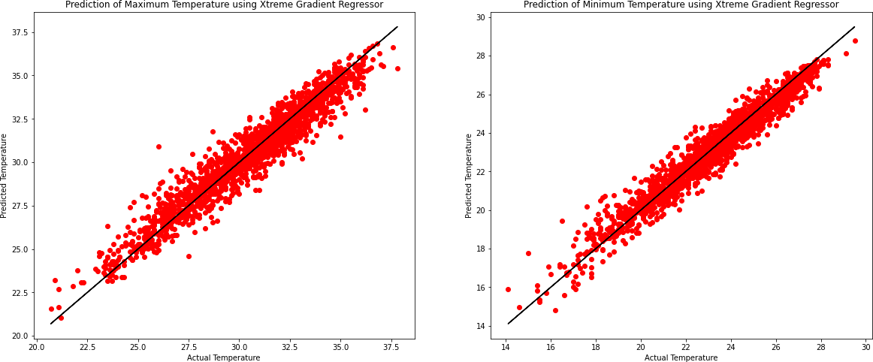

[ ]:

### Concluding Remarks

There is high Bias in our model for this dataset as we are getting a very good R2 score but K- Fold cross validation score is quite low. Even though we have removed outliers and used ensemble techniques and reduced biasing to the minimum, still it remains.